

Odyssey – Radiation Management System Guide
This guide is to support the Safety Office Radiation Team, Senior Radiation Protection Supervisors (SRPS) and Radiation Protection Supervisors (RPS) in navigating and using the University’s Radiation Management System, Odyssey.
Table of Contents
1.0 Introduction 4
2.0 System Configuration 5
2.1 Departments 5
2.1.1 The EA Environment Agency 5
2.1.2 Geological Specimens 6
2.1.3 Safeguards and The ONR Office for Nuclear Regulation 6
2.1.4 Structure 7
2.1.5 Associations 9
2.1.6 Logging In 10
2.1.7 Departments 12
2.1.8 Add Department Limit 13
3.0 Inventory Management 27
3.1 Unsealed Sources 27
3.1.1 Unsealed Sources Process 28
3.1.2 Unsealed Source Inventory Listing 29
3.1.3 Add a new Unsealed Source 34
3.1.4 Edit Unsealed Source 46
3.1.5 Geological Specimens 47
3.1.6 Create an Aliquot – Split Unsealed Source 48
3.1.7 Create an Aliquot and Send to Waste 54
3.1.8 Change of State and Dilution of Unsealed Source 58
4.0 Waste Management 60
4.1 Bin Inventory 60
4.1.1 Add a New Waste Container 60
4.1.2 Accumulation Date 63
5.0 Sealed Source Inventory 64
5.1.1 Add Sealed Source 65
5.1.2 History 71
5.1.3 Documents 71
5.1.4 Labels 72
5.1.5 Comments 72
5.2 Leak Tests and Contamination Surveys 73
5.2.1 Add a leak test 73
5.2.2 Add a Contamination Survey 73
6.0 Radiation Protection Instruments (RPI) / Equipment 74
6.1 RPI 74
6.1.1 Add New RPI 75
7.0 Machine Management 79
7.1 Machine Listing 79
7.1.1 Add Machine 80
8.0 Reporting 85
8.1 Report Listing 85
9.0 Inventory Templates and Configurations 88
9.1 Adding Inventory Templates 88
9.1.1 The Safeguards Inventory Template 88
9.1.2 The HASS Template 88
9.1.3 Geological Specimens Template 88
10.0 Permissions, Worker, S/RPS 90
10.1 Permissions Highlevel 90
10.1.1 User must have work registration AND be added to Department Limit 90
10.1.2 Unsealed Sources Permissions 90
10.1.3 Sealed Sources Permissions 90
11.0 APPENDIX 91
11.1 Department Structure 91
12.0 Document History 92

Introduction
Odyssey is Oxford’s Radiation Management System. A central system to record and manage the University’s radiation-related data including registered workers, materials waste, machines and radiation protection instruments.
All radiation host departments will have access to the system and be required to keep their department records up to date. Only registered radiation workers with an Oxford Single Sign-On (SSO) will have access to the system.
Note: In the first phase of implementing the system only the Safety Office Radiation Team, Senior Radiation Protection Supervisors (SRPS), and Radiation Protection Supervisors (RPS) will have access to Odyssey.
Odyssey is a cloud-based system provided by Versant Physics, an American software company.

System Configuration

Departments

The EA Environment Agency
The University of Oxford is bound by legislative guidance surrounding the holdings and use of radioactive materials and waste. The legislation is directed through the Environment Agency with a set of Departments that provide the controlling limits for holdings and use of radioactive materials and waste.
The Departments are based on geographical location and are specific to a number of buildings within that location.
Each Department is tailored to the specific activities that take place.
The University of Oxford currently holds the current paper permits.
- 5 Unsealed Source Permits
- 4 Sealed Source Permits
- 1 Category 5 Permit
In addition to this the Environment Agency provide an Exemption Order which defines a set of limits for material to be held under exemption conditions. The Exemption Order is applied to each individual building, hence each building has an Exemption Order limit.
Each year, In February, the University of Oxford must provide a return to the EA that describes the full radioactive waste activity for the year. In addition to this, the EA may inspect the University of Oxford and any one of its Permitted locations at any point during the year and require evidence of holdings and use against the limits given to the department, alongside the waste activities.
To amend an EA Permit, an application must be made to the EA for a “Variation”. If successful, the Permit is updated and referenced with a reference suffix at the end of the permit number.
Each Permit is broken down into an agreed set of limits that is given to each Department. This is referred to in the Odyssey system as a “Department Limit”.
The Departments must operate within the limits given to them. Each month they will provide the Safety Office with Source Accountancy Records to confirm their holdings and waste disposal records and to confirm that they remain within their allocated limits.
The source accountancy confirmation and confirmation of waste accumulation and waste disposal to drain and to air will be in the form of a report generated for each department.
Different reports deal with different elements of this process and is further explored in the reporting section below.

Geological Specimens
As at 25/04/2025, Geological Specimens (Rocks) are no longer required to be held under Safeguards regulations.
Rocks contain naturally occurring radionuclides including (but not limited to) Uranium and Thorium. It has been agreed that the University of Oxford will maintain a detailed catalogue of these items in the Digital Asset Management application referred to as EMU. In addition to this, a limited set of data relating to each rock will be kept on the Odyssey system in order to keep track of radiological activity. The two data sets are aligned with a common ID.

Safeguards and The ONR Office for Nuclear Regulation
The ONR provides regulation in regard to nuclear material only. This regulation is referred to as Safeguards. Safeguards accountancy records must be available at any given point in time should the ONR wish to inspect the University of Oxford premises.
In addition, the regulation requires nuclear materials to be reported annually via:
- PIL – Physical Inventory Listing, in regard to holdings
- MBR – Materials Balance Report in regard to movement.
The materials are reported by Category as follows:
Category Code | Element | Description | Limit
D | Udep | Depleted Uranium  (U-235 containing less than 0.7%) | 350Kg
N | Unat | Natural Uranium | 100Kg
L | Ulow | Low Level Uranium  (U-235 enriched to less than 20%) | 1Kg
H | UHigh | High Level Uranium  (U-233 & U-235 enriched to 20% and above) | 5g
P | Pu | Plutonium | 5g
T | Th | Thorium | 200g

The nuclear materials include both sealed and unsealed sources and may be held under any of the EA Permits or fall within the EA Exemption Order.

Nuclear Holdings may be held as follows:

- EA Sealed Source Permit
- EA Unsealed Source Permit
- EA Exempt Sealed Holdings
- EA Exempt Unsealed Holdings
- EA Category 5 Permit
- EA Category 5 basket on an EA Source Permit

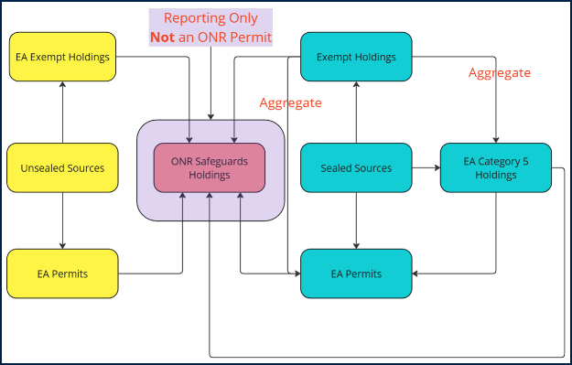

Structure
Structure starts at the University of Oxford level and is based on geographical location.
- The University of Oxford has a number of Departments.
- A Department may be self-contained or may have a number of Sub-Departments.
- Each Department has one or more Buildings.
- Each Building has one or more Rooms, Labs and Waste Stores.
- A Department may share a Building with another Department and maintain a set of rooms within the shared building.
- A Department may share a Room, Lab or Waste Store within a shared Building with another Department.

Site Structure
All Departments, Buildings, Rooms, Labs and Waste stores are entities referred to as “Sites”. The University of Oxford will sit at Top Level in the Site Structure and the Departments will sit in the structure underneath this. The Departments all sit as Primary Sites, with the Buildings and Rooms, Labs and Waste Stores shown underneath.
In the example below, the Worker will log into the Pathology Dunn School Department and have visibility to 4 Buildings and have access to 14 Rooms, Labs and Waste Stores.
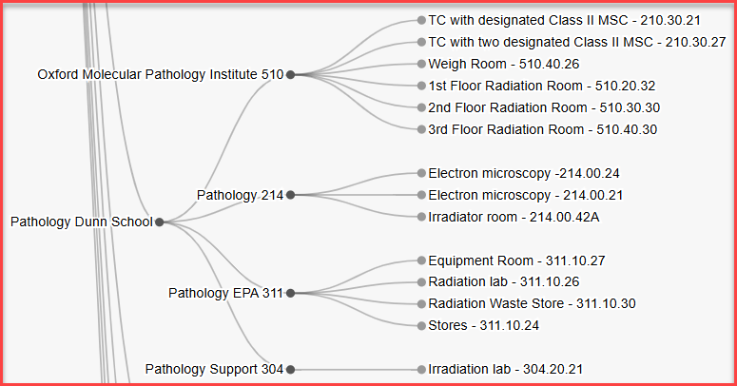
In the case where a Building is shared, the Building will also be made a Primary Site within the system and must also be given an Association to the Building (See below). This will allow the Workers of both Departments to have visibility of Rooms, Labs and Waste stores to which they have been given access.
In the example below the Worker is located in the JR Hospital Main Building and will log in to either of the Departments RDM Cardiovascular Medicine or Surgical Sciences. This will enable to the Worker to view any of the 4 Rooms/Labs within the JR Hospital Building 622 as defined in their Department limit.
This is enabled via 2 things.
- Through the JR Hospital Main 622 Building being listed as a Primary Site, which sits as a sibling alongside the RDM Cardiovascular Medicine and Surgical Sciences Departments.
- Through the creation of an “association” between the Department and the Building.
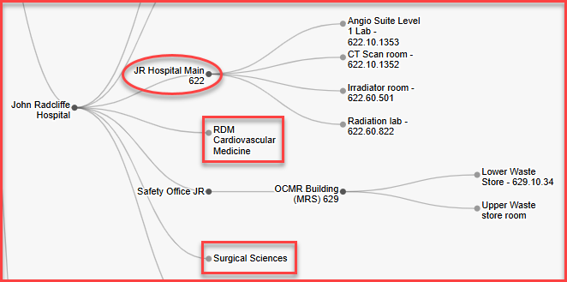

Associations
To enable visibility of a shared Room, Lab or Waste Store an “Association” needs to be created in the System between the Department and the Shared Building. This is achieved through editing the Department Site (from the Site Structure) and adding an “Association” to the shared Building. Note: please ensure that an “Association” must be created for each Department that shares a Building.
Note: please ensure that the association is created on the Department record and that it cites the Building site. Do not create an association on the Building record citing the Department as this will cause users in both Departments to be able to view the personal details of the other Department through the Worker reporting.

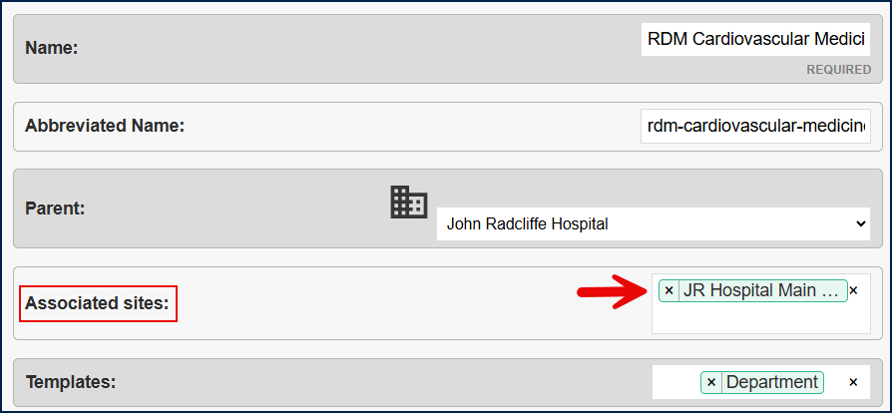

When the Department is created, the Department will dictate exactly what Rooms, Labs, Waste Stores should be visible when using the Department. If the “Association” has been created and the Room, Lab, Waste Store has been added to the Department, the Worker will have visibility of the Room, Lab, Waste Store when logging into the Department on the System.
Please note:
- A lab will only be visible for use with inventory, once it has been set for use with Sealed and/or Unsealed Sources.
- A room will only be visible when adding a machine to the system, once it has been set for use with machines.

Logging In
When logging in to the system, please ensure that you are in the correct Department in which you wish to work. For example, if you wish to “add inventory” to the “Biochemistry Department”, please make sure that you are in the Biochemistry Department.

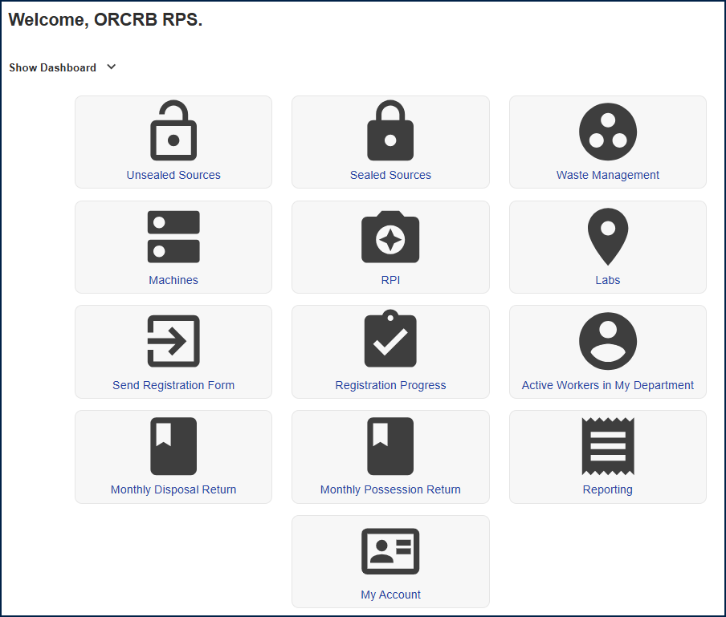
To do this, click on the Department drop down which will display underneath your name on the top right-hand side of the screen when you mouse over your name.
Please note that (S)RPS’s and Workers will have only have visibility of sites for which they have permission to access.

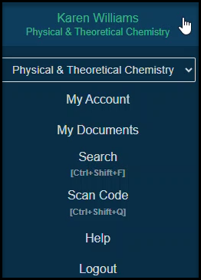

All Departments and Buildings are visible from this drop down as all Buildings are created at “Primary” level. This has be done to facilitate the instances where multiple Departments share a Building.
A user in a Department will see only the Departments and Buildings to which they have an association.
The Safety Office and Administrators will see the entire list.

Departments
Permits are broken down into a set of limits given to each Department. These limits are found in the Departmental Limits Section within Odyssey.
Each Department Limit is defined as follows:
Inventory Type | Department Location | Department
UNSEALED | JR | Department Name
UNSEALED | CSA | Department Name
UNSEALED | Churchill & ORC | Department Name
UNSEALED | NOC | Department Name
HEADROOM UNSEALED | JR | Department Name
HEADROOM UNSEALED | CSA | Department Name
HEADROOM UNSEALED | Churchill & ORC | Department Name
HEADROOM UNSEALED | NOC | Department Name
SEALED | JR | Department Name
SEALED | CSA | Department Name
SEALED | Churchill & ORC | Department Name
HEADROOM SEALED | CSA | Department Name
HEADROOM SEALED | Churchill & ORC | Department Name
EXEMPT | Building Name | Department Name
CATEGORY 5 | CSA – History of Science | Department Name
CATEGORY 5 | Churchill & ORC – RRI / PRoX | Department Name
GEOLOGICAL SPECIMENS | CSA | Museum of Natural History

There are currently 68 Department limits held against Departments in the system.
With regard to the Exemption Order a set of limits must be created for each Building that utilises the Exemption Order. There is only one set of limits created for each Building and the limits are identical for each Building.
In the case where a Building is shared between Departments, Workers from both Departments will be able to view the limits created for the Building. They will also view all inventory held against the Exemption limits for the Building (regardless of Departmental ownership).
This will ensure that the Building Department limit is not exceeded.

Add Department Limit

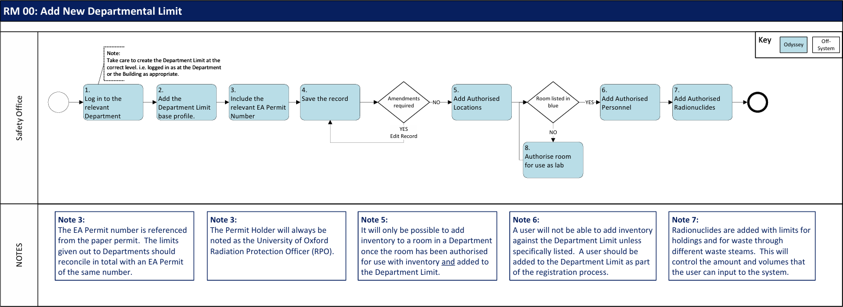

The Safety Office will add/edit Department Limits via:
- Odyssey > Department Limits > Active Department Limits - Add Department Limit.

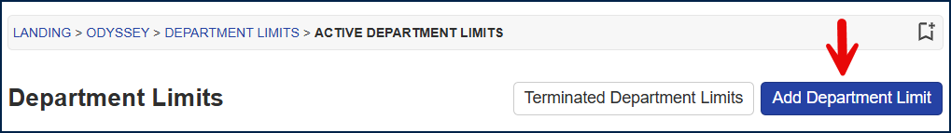

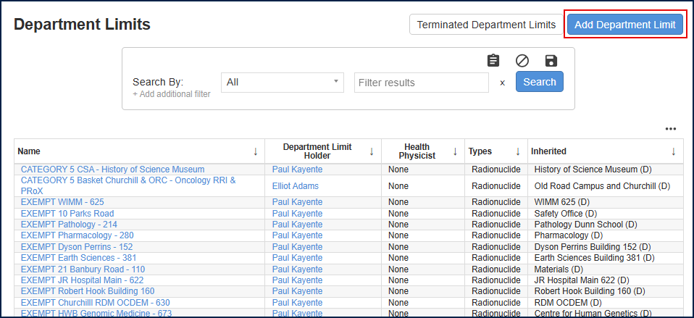

All Departmental limits are shown on the landing page unless using the search criteria to narrow the selection. This is also dependent on the level that you are logged in as. To see all Department Limits, the user must be logged in at University of Oxford level. To see all of the limits for a specific Department, the user must be logged in at the Department level.
To create a Department Limit, first create the base Department Limit profile, then add the subsequent detail for the rooms, radionuclides and users to be able use the Department Limit.
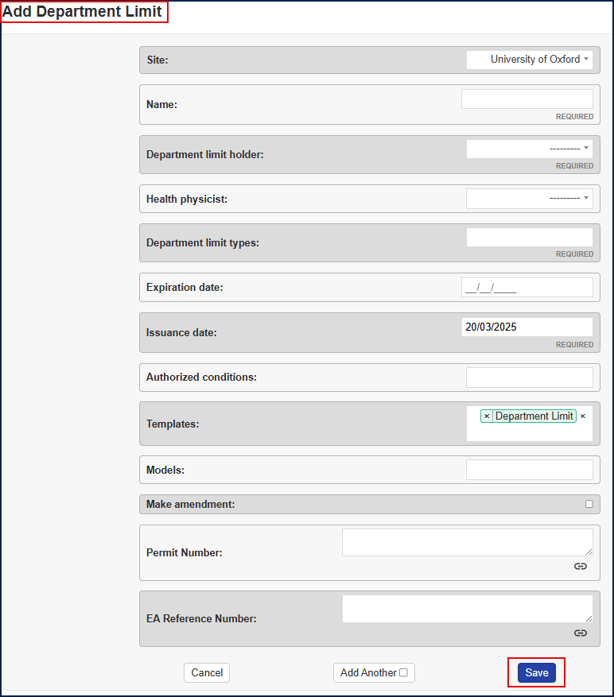
12
11
10
9
8
7
6
5
4
3
1
2

Site
1
This is the level at which the Department Limit is set. All Exempt and Category 5 Limits will be at Building level, so the “Site” in this case will be the Building Name. All other Limits will be at Department level.

Name (Required Field)
2
This follows the naming convention: Exempt / Category 5 / Sealed /Unsealed
    - then by the Area
    - then by Department / Building Name
Department Limit Holder (Required Field)
3
This is the current University RPO, given that this role is currently responsible for allocating each Department with a set of limits.
Health Physicist
4
Ignore. Not currently used.
Department Limit Types (Required Field)
5
This is defaulted to Radionuclide and should not be changed.
6
Expiration Date
This should remain blank unless the EA Permit states an expiry date. If this is field is populated, the limits will not be usable beyond the date and it will not be possible for the Department to hold inventory.
Issuance Date (Required Field)
7
This is the date of issue for the EA Permit.
Authorised Conditions
8
Ignore. Leave Blank.
9
Templates
This is automatically populated with the “Department Limit” template. This template currently has 2 fields attached to it. The Permit Number and the EA Reference Number. Should further fields be required in the future to be added to Department Limits, they can be added to this template. All templated fields will appear on the Department Limit screen below the “Models” field.
Models
10
Ignore. Leave Blank.
Permit Number
11
This is the EA Permit Number.
EA Reference Number
12
This is iteration of the EA Permit e.g. /V001. Hence it will the permit number in full followed by the iteration.

Department Limit profile page

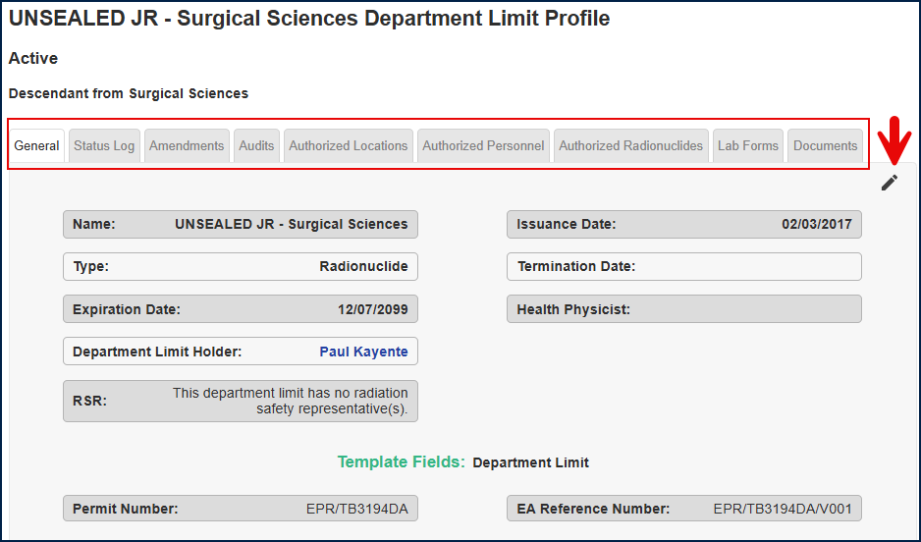

Authorised Locations
Once the Department Limit has been created, select the Authorized Labs to add the relevant rooms and labs to be used with the Departmental Limits.

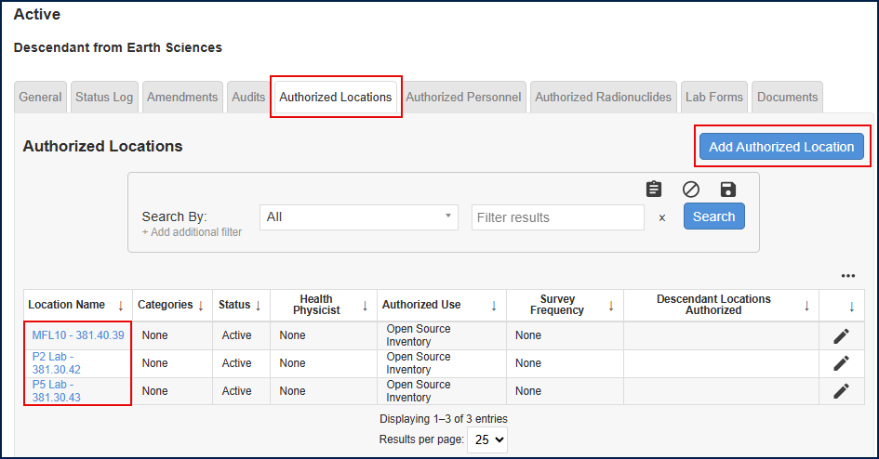

Once added the rooms will all be listed as shown. Note: if the room is listed in blue, then it has been authorised for use as a lab with inventory. If the room is listed in black, then it will not be usable until it has been authorised as a lab. To authorise a location as a lab, the user must visit the LABs module and add the room to be authorised as a lab.
Select Add Authorised Location to add the authorised lab to the Department Limit. If a room is no longer required to be used against the Department Limit, click on the pencil icon to edit and delete the room.
The exact same logic applies to waste sites. A room must be authorised as a Waste Site in the Waste Management module under Sites. Once authorised, it can be added to the Department Limit as previously described by selecting Add Authorised Location.

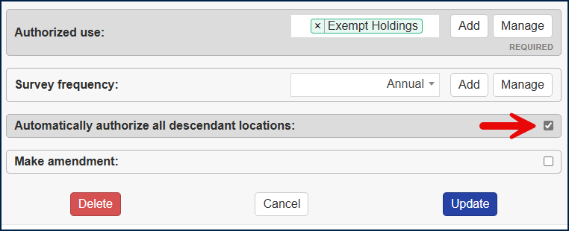

Note: for the Exempt Limits only, the location added will be the Building i.e. not a room or lab. Select “Automatically authorise all descendant locations” with the tick.
This is to ensure that every room in the Building is covered under the one Exempt Limit. Therefore, there will only ever be one Exempt Limit per Building.
Please ensure that this field remains unticked for the Sealed and Unsealed limits.
Note: the descendant locations does not work for Waste locations that are not set up as labs. These are required to be manually added if they are required. In the University of Oxford set up, it is not required to dispose of exempt waste directly to a waste store that is not a lab. Exempt materials will be disposed of directly into a waste container within a lab.

Authorised Personnel
On the Authorized Personnel tab, select ‘Edit Authorized Personnel’ to add users to allow them to be listed as owners of objects on the department limit.

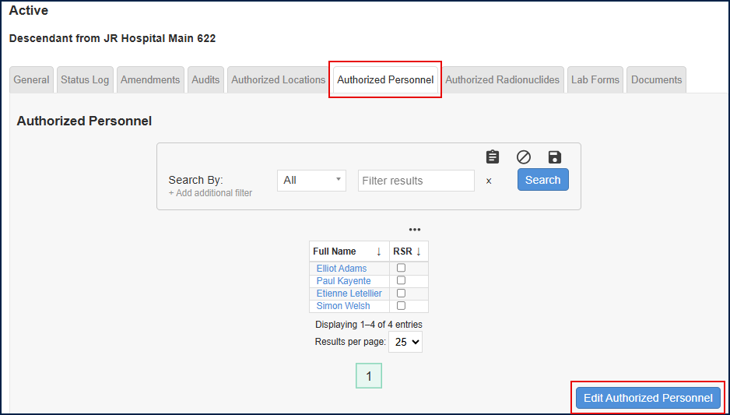

Click the Edit Authorised Personnel tab to open the next window. To add another user, please click into the white space and use the scroll bar to move up and down through the list of users available to add to the Departmental Limit.
Note: please ensure that you are in the correct Department location in order to see the relevant list of Users.

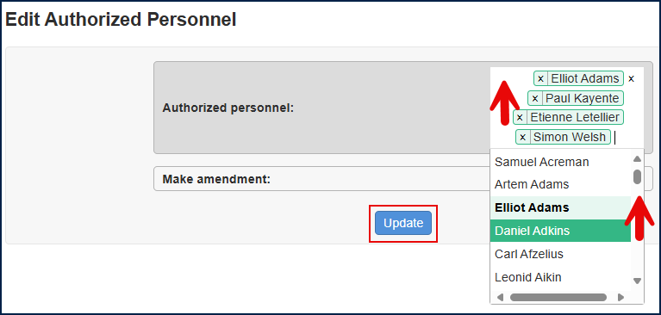

Each time a new User is added to the system, they will need to be added to the relevant Departmental Limits.
At the time of writing, this remains a manual process that will be controlled by the Safety Office as they approve new Worker Registration forms.

Authorised Radionuclides
On the Authorized Radionuclides, select ‘Add Authorized Radionuclide’ to add the authorised sources, source groups, limits and waste limits. Below is the summary of all radionuclides added to the Department limit page.

Note:
Radionuclides limits must be specified on the department limit itself, but machines and equipment remain outside of this process as they are not controlled via Departmental limits.

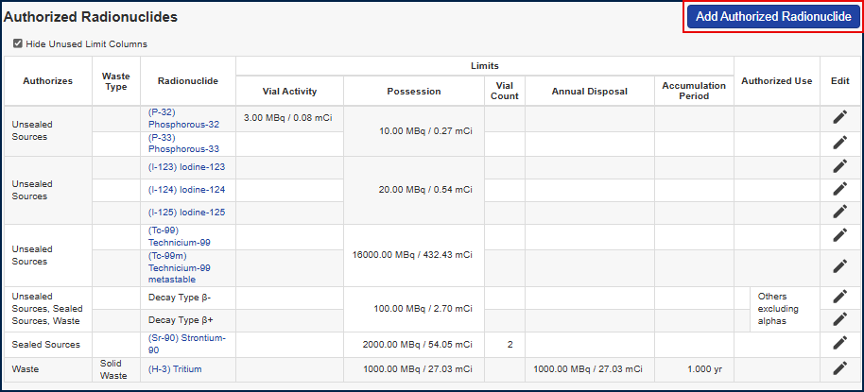
4
2
1
3
11
10
9
8
7
6
5

Authorises
1
This describes the activity that is authorised and will be one of 3 categories: Unsealed Sources, Sealed Sources or Waste.

Waste Type
2
If the authorisation is for waste, this field will describe the type of waste. This may be one of 4 types of waste. Solid, Liquid, Organic Liquid, Gaseous. If the field is left blank, then all types of waste are included. Note: it is not possible to select 2 or 3 types of waste in this field. The selection is either all types of waste or a single waste type.

Radionuclide
3
This is the radionuclide against which the limit specified is to be applied.
4
Limits
This section describes the actual limits set and will display only the populated columns

Vial Activity
5
This is used to control the amount activity per inventory item.

Possession
6
This is used to limit of activity for the radionuclide.

Vial Count
7
This is used to the number of items.

Disposal Period
8
This will vary depending on what is required.

Accumulation Period
9
This is the period of time over which the waste can be held as accumulated waste.

Authorised Use
10
This is to define a specific use case for the limit. Note: there may be different use cases for the same radionuclide.

Edit
11
Use the pencil icon to edit the Department limits once they have been created.
Note: every time a limit is edited, the whole thing will revalidate to ensure that all required fields are populated and that all fields are calculating correctly.
Note: it is not possible to remove a limit if there is already inventory and/or waste held in the system which reference the Department limits.

Add Authorised Radionuclide

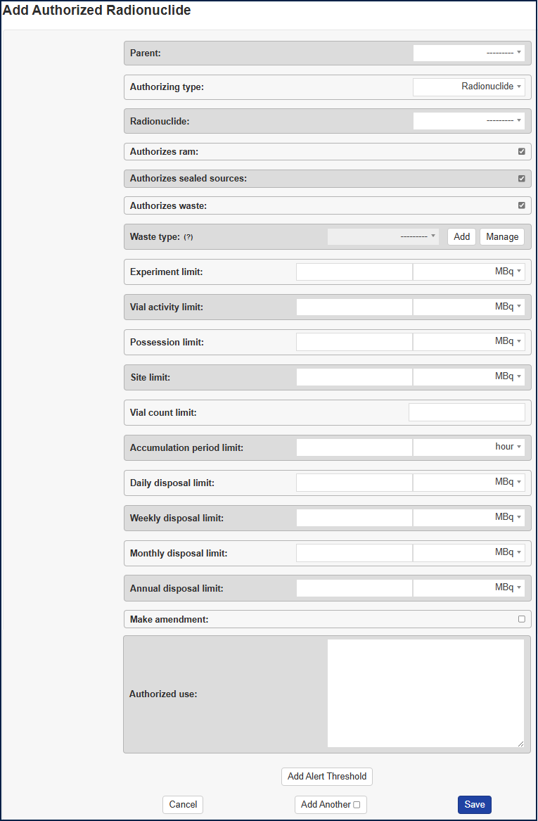
20
19
18
17
16
15
14
13
12
11
10
9
8
7
6
5
4
3
2
1

Parent
1
This is used to group limits. For example:
P32/P33 is a group where there is one limit to cover both radionuclides. A P32/P33 parent is created with the limit. The individual radionuclides P32 and P33 are then added against the parent ID so that both with utilise the one limit.
In the example below there are multiple groups shown.
- Unsealed Sources is a “parent” that sits at the top of the hierarchy.
- P32/P33 is a parent that sits under Unsealed Sources and has 2 children, P32 and P33.
- Others Excluding Alphas is a parent that sits under Unsealed Sources and has 7 decay types listed as children.
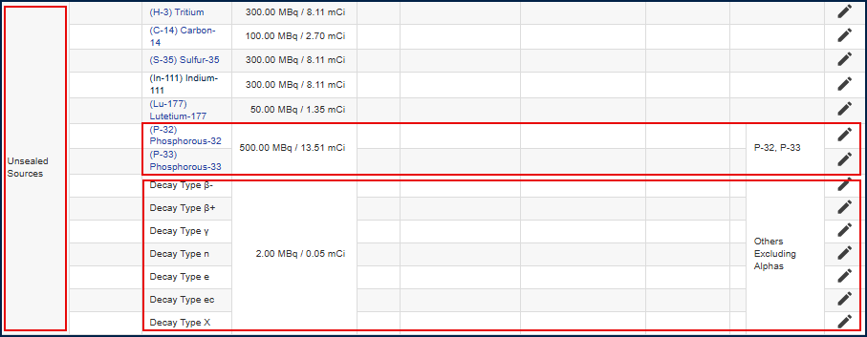
- 5 individual radionuclides sit directly as children underneath Unsealed Sources, including Tritium and Carbon-14 etc.

Note: the “parent hierarchy” is also used to control waste by waste type. The example below shows the limits grouped by Organic Waste with a “parent” used to control “Others Excluding Alphas”, whilst Tritium and Carbon-14 are listed as singular radionuclides with individual limits.

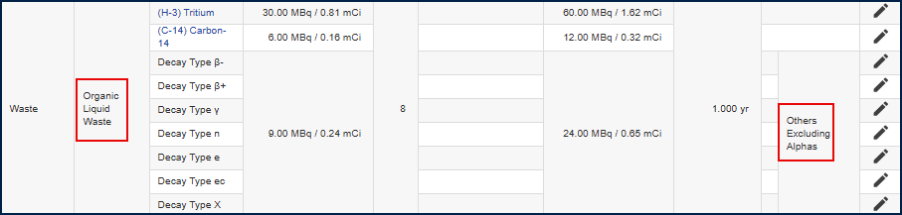

Authorising Type
2
This is either by “radionuclide” or “decay type”. This allows the addition of a radionuclide by decay type rather than having an individual radionuclide limit created.
For example, if a limit is set for decay type “alphas”, but no specific radionuclides are listed, then adding the radionuclide Americium-241 into inventory is possible as long as it is within the limit cited by the decay type alphas.

Radionuclide
3
This is the name of the radionuclide. Note: all radionuclides have been added to the system with their respective half-lives. Therefore based on the inventory added, the system will calculate the relevant activity of the radionuclide.
4
Authorises RAM
Select this field if the limit to be added will apply to Unsealed Source holdings of a radionuclide. Note: this should not be ticked if the limit doesn’t include Unsealed Sources and is to be applied to Sealed Sources or Waste.

Authorises Sealed Sources
5
Select this field if the limit to be added will apply to Sealed Source holdings of a radionuclide. Note: this should not be ticked if the limit doesn’t include Sealed Sources and is to be applied to Unsealed Sources or Waste.

Authorises Waste
6
Select this field if the limit to be added will apply to Waste holdings and Waste disposals of a radionuclide. Note: this should not be ticked if the limit is to be applied to holdings of Sealed or Unsealed Sources.
7
Waste Type
If the “Authorises Waste” field as above is ticked, the drop down for Waste Type will allow selection of waste streams as below. Note: if a waste stream is not selected, then the limits put in will apply across all waste streams.
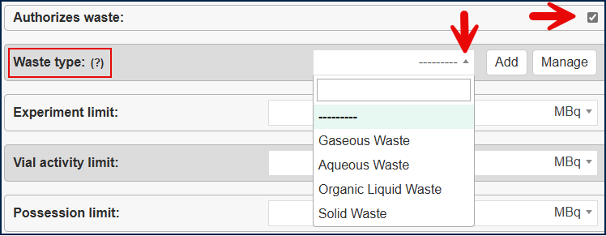

Experiment Limit
8
Currently this is not used and is for information only.

Vial Activity Limit
9
This is the maximum value for each inventory stock.
10
Possession Limit
This is the maximum value for possession of holdings of a given radionuclide across all sites on a Department Limit profile.

Site Limit
11
This is the maximum value for possession of a radionuclide per site on the Department limit. i.e. a limit for each lab and waste store.

Vial Count Limit
12
This is used for two things. The maximum number of inventory stocks for the radionuclide if applicable to holdings or the maximum number of waste containers if applicable to waste streams. Note: the Sealed Source Department limits currently show a vial count as this is used to represent the number of each radionuclide source.
13
Accumulation Period Limit
This is defaulted to “Year” but can be amended to “Day” or “Hour”. The majority of the limits are defined as annual. This reflects the length of time that the waste can be held as accumulated waste, which in most cases is 12 months. Note: aqueous waste is generally held only for 3 months.
Note: the Safety Office have a policy to collect waste from locations after 9 months or when the bin is known to be 75% full. The system is able to alert users in regard to the time frame but not in regard to capacity as it has no way of knowing how full the bin is.

Daily Disposal Limit
14
This is the amount of activity for the radionuclide that can be disposed of on a daily basis. Note: it is only the gaseous limits that are cited with a daily limit.

Weekly Disposal Limit
15
This is the amount of activity for the radionuclide that can be disposed of on a weekly basis.

Monthly Disposal Limit
16
This is the amount of activity for the radionuclide that can be disposed of on a monthly basis.

Annual Disposal Limit
17
This is the amount of activity for the radionuclide that can be disposed of on an annual basis.

Make Amendment
18
This is not used. Ignore.
19
Authorised Use
This describes how the radionuclide to be added into inventory will be used or grouped. There are several common groups across the Department Limits.
“Iodines” – has a single set of limits and generally includes I-123, I-124, I-125, I-129 and I-131 (depending on the Department Limit, some are not included)
“P-32, P-33” – has a single set of limits and includes the radionuclides P-32 and P-33
“Others Excluding Alphas” - has a single set of limits and includes Decay Types β-, β+, γ, n, e, ec and X.
The Exempt Limits have a large category that covers both Sealed Sources and Waste, that is called “Exempt Limits Unspecified Source” for which there is a 4MBq holding limit of individual stocks and waste aliquots with an overall possession limit of 200MBq of them all combined. The time limit for waste possession is 182 days (6 months).

Alert Threshold
20
This specifically applies to waste limits and is set against the accumulation period limit. Waste containers are held for no longer than 12 months. Therefore, an alert is set up against the accumulation period to notify the user at 9 months that the waste will need to be removed within the next 3 months.
Select the limit field as “Accumulation Period”, set the Percentage to “75%” and select who should be notified in regard to the limit. E.g. “Admins”.
In this example, the system will notify the Safety Office when the waste item reaches the 9 month period.
Note: at the time of writing, new functionality has been added to the display to show a bell icon against each waste item where an alert has been set. Mouse over the icon to see the limit set e.g. “75% of accumulation period”.

Inventory Management

Unsealed Sources
Unsealed sources may be held under an EA Department Limit or under the guidelines given by the Exemption Order. The Exemption Order has been defined as a series of identical limits as described in the system under the “Exempt Limit” per building.
The majority of our nuclear material is held under the Exemption Order as Uranium compounds and Thorium salts, as they are very low quantities. For example, Uranyl Acetate.

Nuclear materials, (Uranium, Plutonium and Thorium), that are held as Unsealed Sources, or Exempt Sources, will also be subject to ONR scrutiny and so will also be shown on the Safeguard reports.

Unsealed Sources Process

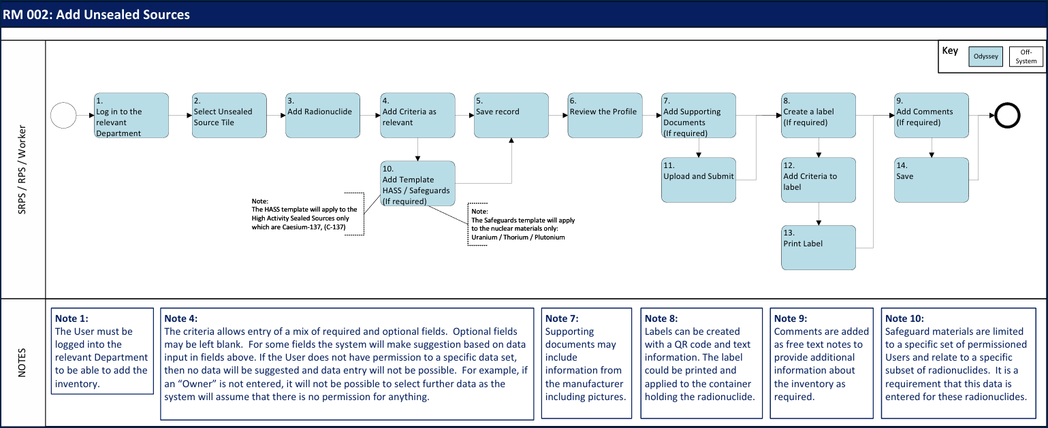

Unsealed Source Inventory Listing
Action
    - Click on the Unsealed Sources tile to open the Unsealed Source inventory.
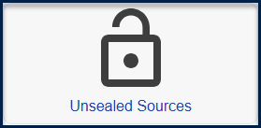
Note: The landing page for Unsealed Sources will open with a list of inventory for all current Unsealed Sources to which the user is entitled to see for their User profile and Department that they are logged in to. For example, an SRPS that has visibility of multiple Departments i.e. Chemistry which oversees 4 Departments will be able to see inventory for all 4 Departments. Whereas the RPS in one of those Departments will see only that Department’s inventory.
Unsealed Source inventory listing page. This page will automatically open to show all active Unsealed Sources.
Note: any items in blue on the page are clickable links that will take the User to another destination in the system, providing they have permissions to access.
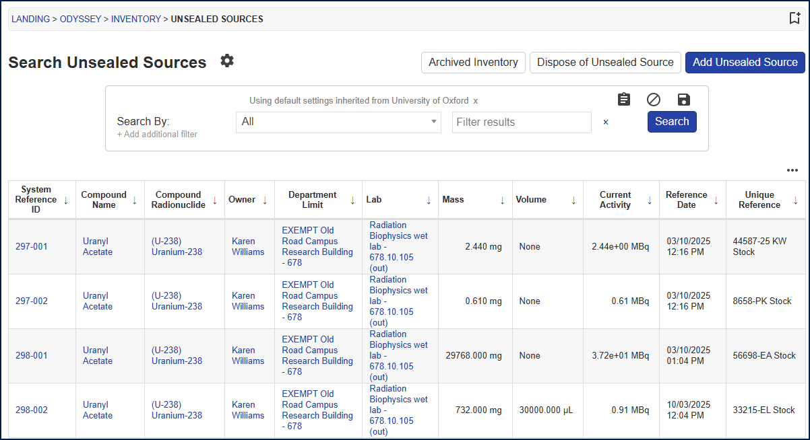
3
5
4
2
1
6
7

The Breadcrumb Trail
1


It is important to keep an eye on the breadcrumb trail as that will inform the User as to where in the system the screen is. Given that it is possible to click on links (any piece of data noted in blue has a link) from a page, the system will navigate to different modules. If the User has no access to the relevant module, and permissions access message will be shown instead.
Archived Inventory
2

Inventory is moved to an “Archived” status, once it is no longer actively held against the Department. This can be achieved through disposal of a source i.e. aqueous disposal to drain or gaseous discharge to air via fume hood or stack. It may also occur when a radionuclide decays to zero and is no longer active. Note point 5 below in regard to configuration of this activity.

All inventory with zero activity will be held as an archived record in order to provide an auditable trail for each radionuclide.
Further instances of archiving may occur when the Safety Office dispose of solid waste offsite to a third party waste operator, or a radionuclide is transferred offsite to another organisation for a collaborative piece of work or because the other organisation has a need for the radionuclide that the University of Oxford does not.

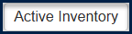

Just as the “Archived Inventory” can be selected, the User can return to the “Active Inventory”, using the field again found on the top right-hand-side of the page.

Search By
3
Filters can be applied to search for specific datasets. For example, a User may wish to search for inventory with a specific “Owner” or perhaps a “Unique ID” or a particular “Compound”.

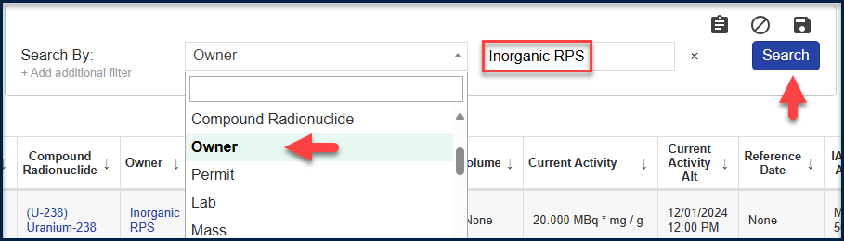
It is also possible to be more advanced with the filtering and select everything that is “not like” or everything that is “exactly like”.
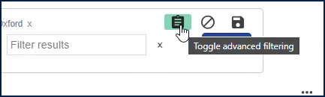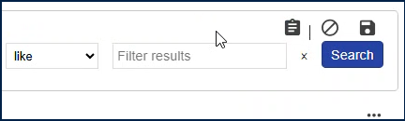
The User can also select multiple filters within the same search e.g. all radionuclides with a specific owner.

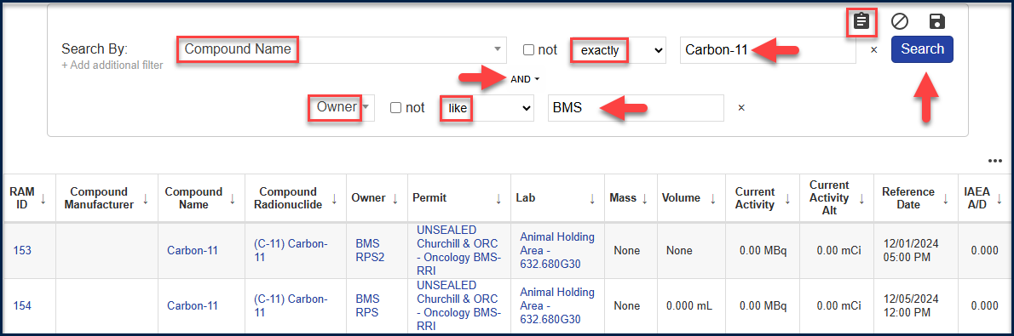
4
System Reference ID
This is the system generated unique identifier for each piece of inventory within the system. The format is 3 digits with a suffix of 3 digits.
Where an aliquot has been made, the system will automatically generate a System Reference ID using the original number of the parent source and incrementally increasing the suffix.

This makes it easy to trace parent and sibling inventory throughout the system.
For example, a parent inventory item may have a System Reference ID #122-000. The subsequent aliquot will have a System Reference ID of #122-001. A further split that may be sent to waste will have a System Reference ID of #122-002. Therefore it is easy to see at a glance that the aliquots and waste items both relate to an original parent radionuclide.

Archive Configuration
5
The Cog shown next to Search Unsealed Sources is available to ADMINS only.
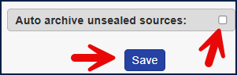

This allows “Auto Archive Unsealed Sources”. When this is selected, the system will automatically move inventory that has decayed to zero to an “Archived” status by adding an “Archived Date” to the record.
If this field is not selected, then any inventory that decays to zero will still remain on the screen in the “Active Inventory” listing until the User individually amends the record using the Edit function. It is a University of Oxford policy decision to leave this field unticked. The user will need to actively amend the status of inventory to “Archived” as and when appropriate.
6
Add Unsealed Source

This is to add a new Unsealed Source into the inventory. Any User can add inventory as long as they are on the department limit and there is availability within the limits. The detail of this is covered in the next section.

Column Configuration
7

For Workers/RPS/SRPS there is a default view that is shown. This has been configured as a site-wide setting across all Departments.
The ADMINS have the permissions to amend this if required to ensure a local setting for a particular Department that is more appropriate to meet their requirements.
An example being where a Department does not hold any inventory recorded in mg and so does not wish to see “mass” on the screen as it is an inappropriate empty column.

Click on the ellipsis 3 dots to “Show Columns”.
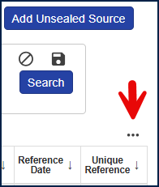
All current columns displayed will be shown at the top and highlighted at the top of the view.
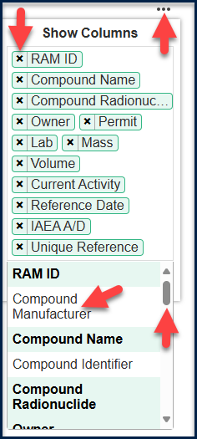
Click into the white space next to any of the highlighted fields and the unhighlighted (unselected) columns will show.
Use the scroll bar to identify any further columns required and/or click the “x” next to a selected column to remove it from the display.
Click on Apply when done and the new column selection will be reflected in the inventory listing display.

Up and Down Arrows
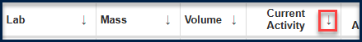
Use the up and down arrows shown next to the names in each column header to sort the data shown on the page in alphabetical order, either ascending or descending as required. For Example, it may be required to sort in order of Activity.

Add a new Unsealed Source
Action
    - Click Add Unsealed Source shown on the top right-hand-side

This will open a standard template to be completed prior to saving the record which will add the source to the inventory.
Some of the fields are mandatory and will have the label “Required”. Other fields are non-mandatory and may be left blank if unknown.
Some fields, the system will make suggestions based on data input in fields above. If the User does not have permission to a specific data set, then no data will be suggested and data entry will not be possible. For example, if an “Owner” is not entered, it will not be possible to select further data as the system will assume there is no permission for anything.
The form is shown below, and each field is explained in detail following the form.

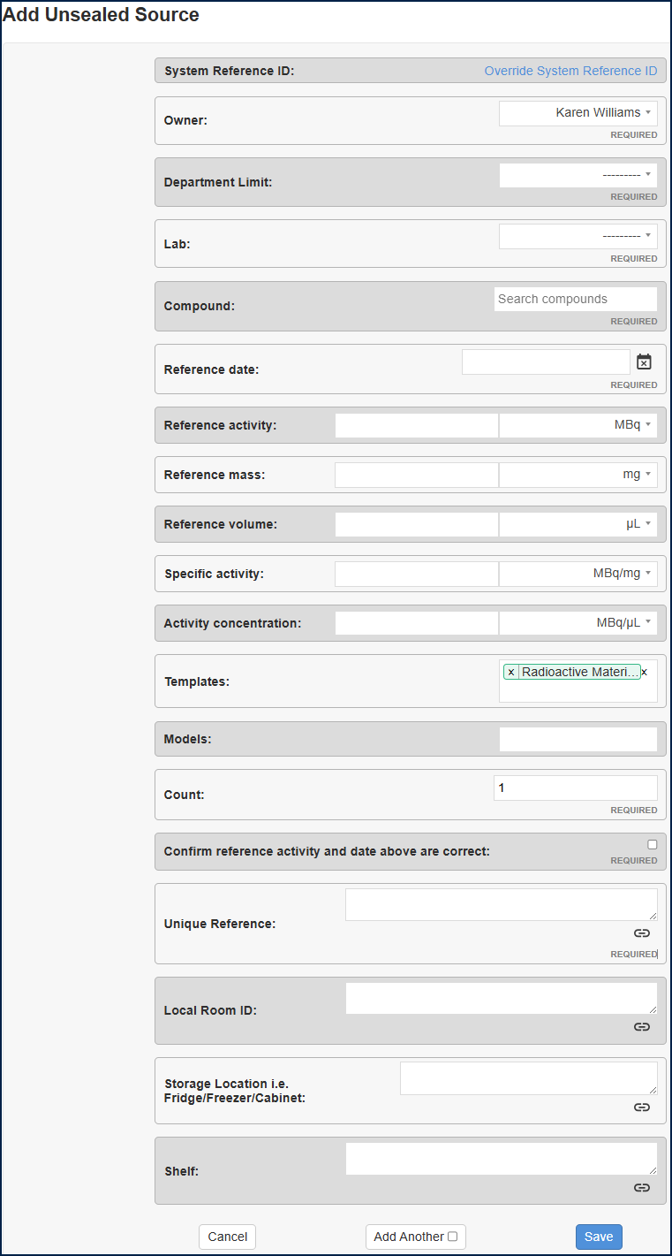
18
19
17
16
15
14
13
12
11
10
9
8
6
7
5
4
3
2
1

System Reference ID
1

This field is automatically system generated. The system uses a sequential numbering system and will apply a 3 digit suffix to the end of each number.
The suffix is used to group a number of sources that are derived from a parent source. This situation will occur when splitting a parent source into Aliquots and/or splitting out a portion of the radionuclide to send to a waste stream.

Note: the numbers are unique and applied across the entire system in sequential order. Therefore, the sequence within Department will necessarily have gaps as the next number will be taken by another Department as inventory is added.

The Safety Office and support functions are the only Users who will see the entire sequential set of numbers.

Owner
2

The owner is the person who is accountable for the radionuclide added to the inventory. This is a required field.

The list of Users available to select in this field will be dependent on the User ID of the person logged into the system and the Department that they are logged into.
When a Worker logs in, this field will be automatically populated with their own User Name, which for the majority of cases will be correct. In the event that an SRPS or RPS is adding the radionuclide on behalf of another User within their Department, this field will need to be amended by clicking on the drop down arrow to select the relevant User.

Note: if this field is not populated, it will not be possible to enter data into subsequent fields as there will be no selections available.

Department Limit
3

This refers to the Departmental limits given to a Department. Each Department is given a set of limits identified by radionuclides that they must adhere to. Therefore, to add a radionuclide to Departmental inventory there must be capacity within the limit set for the radionuclide for that Department.

This field is for the User to identify against which Departmental limit the radionuclide will be added.

It is a required field and the available options will be dependent on upon the User input in the previous field.

Each Worker must be added to the relevant set of Departmental limits in order for their Department limits to be displayed as an option in this field. The Department limit therefore is dependent on the Owner input in the previous field.

Lab
4

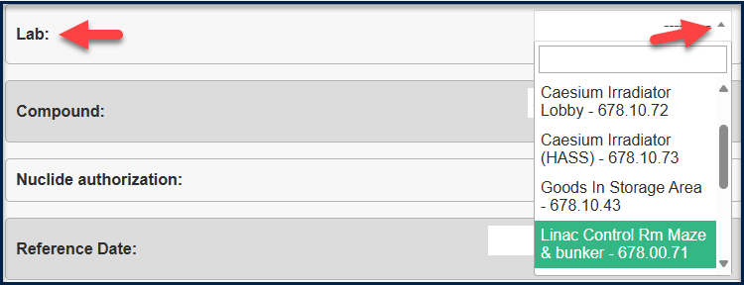

The selection of rooms available from the drop down menu will be dependent on upon the Department limit chosen in the previous field, as the Department limits not only control the radionuclides and the Users who can use them, they also define which labs and rooms are to be associated with use of Unsealed Source inventory.

Compound
5

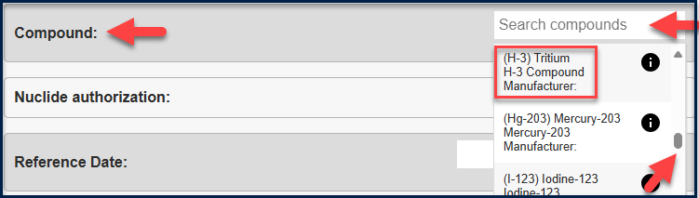

Click into the white space to search for the radionuclide required. There is a scroll bar shown on the right to move up and down through a list of the available radionuclides dependent on the Department limits given.

Note: if it is known exactly what you want without scrolling, type in the first few letters or the identifier. For example, type in “Tri” or “H-3” and the system will return the answer Tritium H-3 compound (given that it is available to select from the Department limits authorised.

Nuclide Authorization

This field will only appear once the compound radionuclide has been selected and will follow the authorisation that has been given from the Department limits. It is a way of grouping authorisation where multiple limits are available for type of radionuclide.

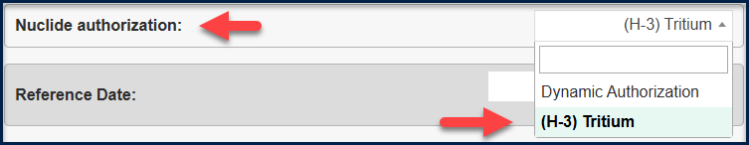

If there is only one authorisation for the radionuclide that will be the authorisation automatically selected. In the example above, there is only one authorisation available for the radionuclide Tritium, hence it is automatically populated.

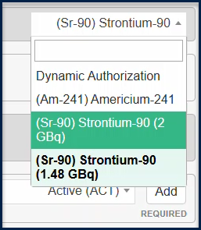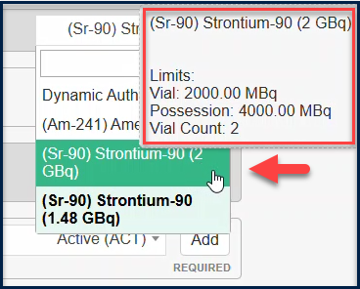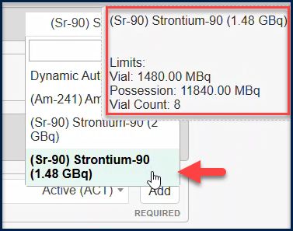

The example above is for Strontium. By clicking on the drop down arrow, it is seen that there are two authorisations available (box 1). The User must select the most appropriate authorisation. i.e. should the entry fall under the 2GB (2,000 MBq) limit (box 2), or the 1.48GB (1,480 MBq) limit (box 3).
Note: the “Vial Count” shown in the above screenshots is the number of inventory items that can be held in the relevant category.

Dynamic Authorization

The system can also assign the inventory item automatically to the most appropriate authorisation. The system will do this by allocating the radionuclide to the lowest value authorisation first until the category is full or the inventory item cannot fit within the value limit remaining for that category.
Reference Date
6

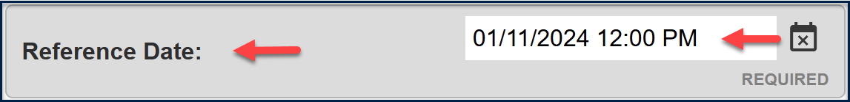

This is the reference date for the system to calculate the half-life of the radionuclide. i.e. the date that the radionuclide came into being.

As best practice, for sources with a half-life of greater than 24 hours the record must be set with the relevant date and set the time as 12 noon. For sources with half-life less than 24 hrs, the record must record the relevant date and actual time if that info is available.

System Calculated Fields

The system will calculate a value based on the inputs given. 2 inputs are required to calculate the 3rd variable.

Reference Activity + Reference Mass = Specific Activity
Reference Activity + Reference Volume = Activity Concentration
Reference Activity + Activity Concentration = Reference Volume
Reference Activity + Specific Activity = Reference Mass
Reference Mass + Specific Activity = Reference Activity
Reference Volume + Activity Concentration = Reference Activity

Note: it may be that only 1 variable is known, in which case other variables must be input manually when known.

Reference Activity
7

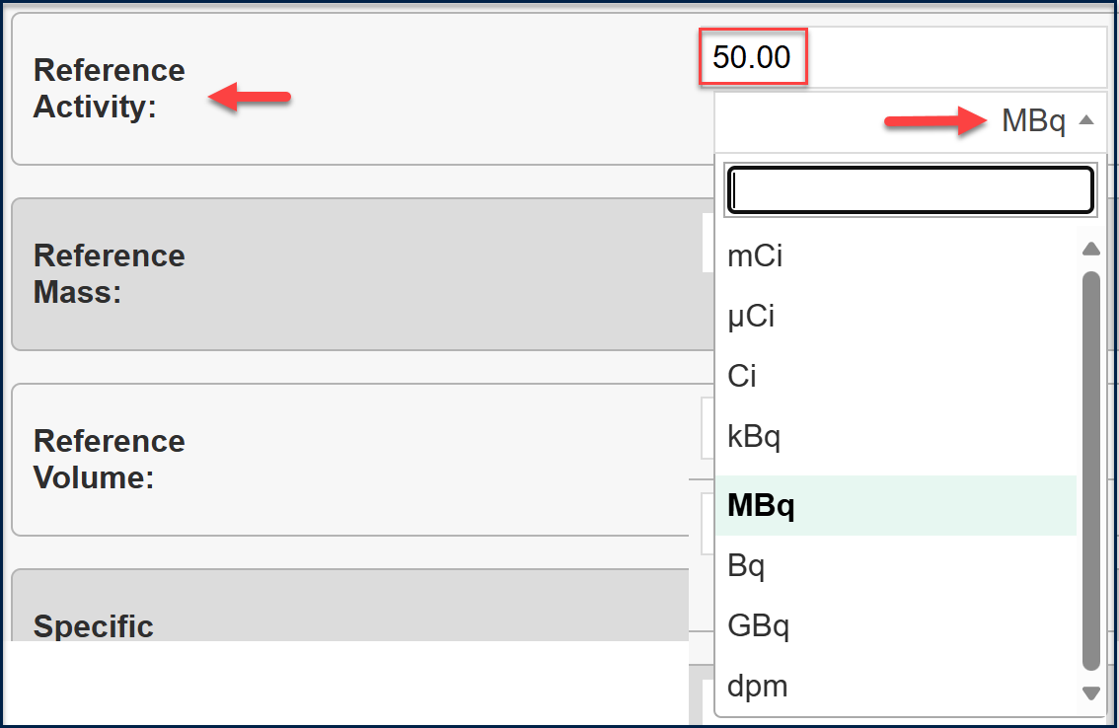

The reference activity is the activity aligned with the reference date and will decay in accordance with the radionuclide half-life. The information can be captured using a variety of units as required. Note: the activity throughout the system will be tracked in the unit of MBq. However, it is possible to capture the initial information in mCi or dpm for example if that is how the data is received from the Supplier.

On the main profile screen, regardless of initial data capture, the information will show as calculated in MBq.
8
Reference Mass

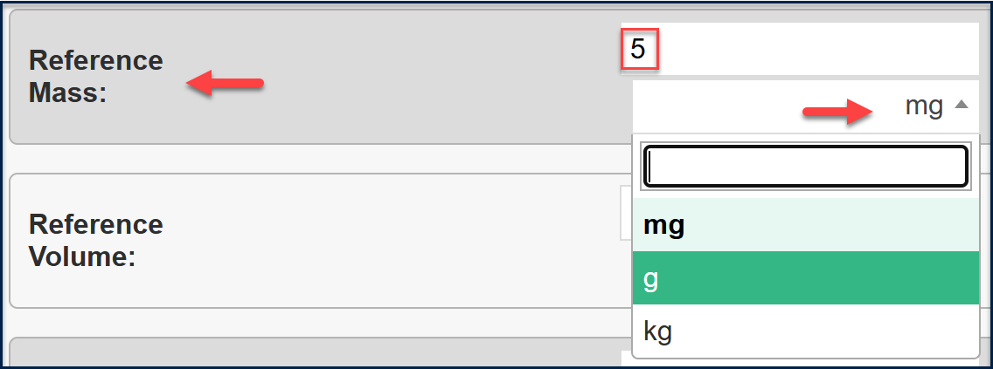

The reference mass is the activity aligned with the reference date and will decay in accordance with the radionuclide half-life. The information can be captured using a the units of “mg”, “g” or “kg” as required.

Note: all nuclear radionuclides – Uranium, Thorium and Plutonium must be captured as MASS. As it is a reporting requirement to confirm this dataset in grams.

If Reference Activity and Reference Mass are captured, the system will automatically calculate the Specific Activity as the next field.

If Reference Activity and Reference Volume are captured, the system will automatically calculate the Activity Concentration as the next field.

Reference Volume
9

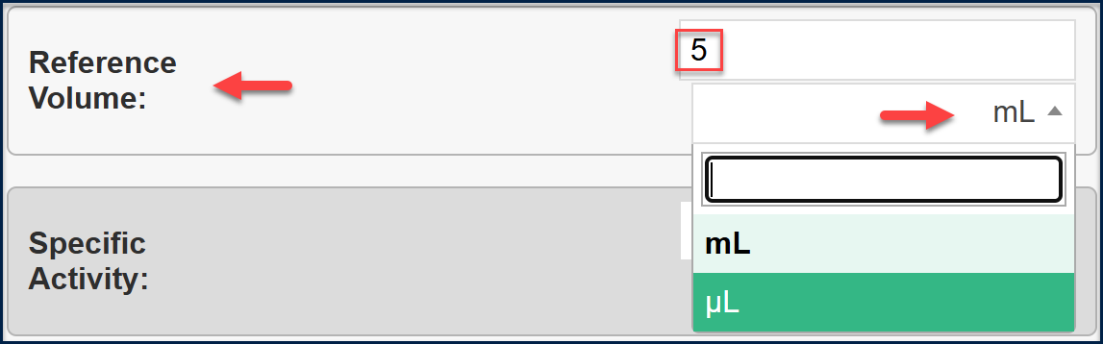
The reference volume is input (if known) in line with the Reference Activity. The unit options are either “mL” or “μL”.
Note: if this value is input, the system will automatically calculate the Activity Concentration field as below.

Specific Activity
10
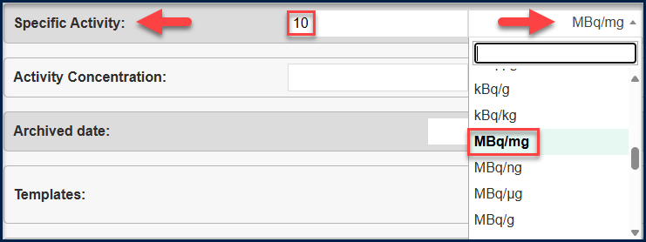
The Specific Activity is based on a calculation of Reference Activity and Mass. The units available for input are multiple and should be based upon the units input in the preceding fields above. The default is MBq/mg and that is what will be shown on the inventory profile page. All values in the system will be tracked using MBq regardless of input.

Activity Concentration
11
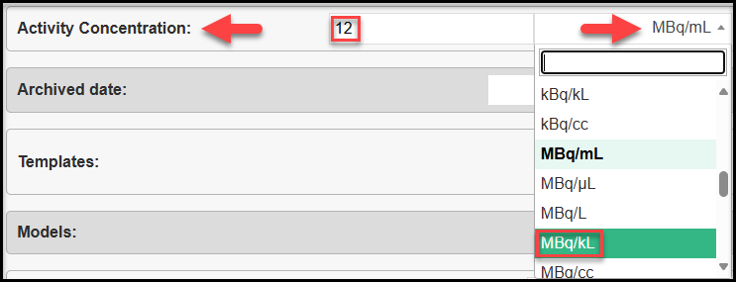
The Activity Concentration is based on a calculation of Reference Activity and Reference Volume. The units available for input are multiple and should be based upon the units input in the preceding fields above. The default is MBq/mL and that is what will be shown on the inventory profile page. All values in the system will be tracked using MBq regardless of input.

Templates
12

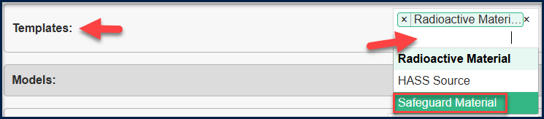
Templates are used to hold specific datasets. The “Radioactive Material” template is used as the base template to capture all fields available for input when adding a radionuclide to inventory. Additional templates may be used for specific Use Cases. In the example of a nuclear radionuclide (Uranium U, Thorium Th, or Plutonium Pu), being added to the system, the “Safeguard Material” template must be added as an additional template. This will allow an additional set of fields that are required for Safeguard reporting.
Note: this will be a Safety Office task to add the Safeguard templates to all inventory sources as they are added to the system.
This is applicable to both Sealed and Unsealed Sources and the activity for the safeguard sources will always be shown in grams.
For further detail on the Safeguard Templates, please refer to the end of this section at 3.1.3.1

Models
13
The Odyssey “model” is used to auto fill template fields. They are useful in a situation in which you want information presented on a profile in template fields and that information is the same across a group/template.
An example of this is with the safeguard materials. Once the Safeguard template is selected, select the Model Category as shown below.
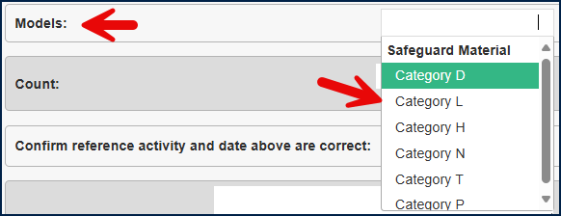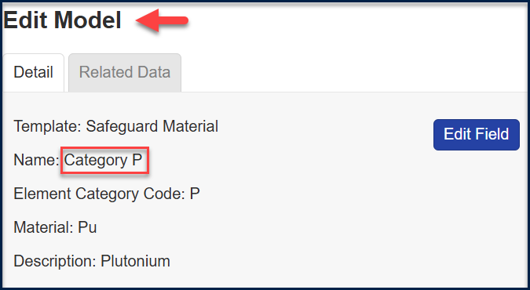
Each category has pre-populated data for 3 fields:
- “Element Category Code,” the “Material,” and “Description” fields
These are automatically populated based on the Model Category chosen.

Count
14
This is the number of radionuclides to be added using this form with an identical set of criteria. It is defaulted to “1” and is a required field. If the number was changed to “2”, this would add 2 entries to the inventory with identical criterial except the System Reference ID would automatically increment.

Confirm reference activity and date above are correct
15

This is a required checkbox to ensure review of the calculated entries in the fields above. It is not possible to add the radionuclide to inventory if this checkbox remains unticked.

Unique Reference
16

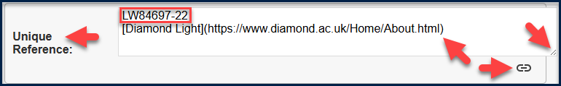

This field is for the manufacturer’s serial number of the radionuclide source to be added into inventory. The field is available for reporting and can be used to search for and identify inventory in the system. It is also possible to add a link into this field for example a link to the manufacturer’s website. Click on the lines in the bottom right corner to widen the box. Input the text name to be displayed inside the square brackets (remove the <> signs)

Note: as best practice it is suggested to input the manufacturer’s serial number, followed by the initials or name of the stock owner. This will aid searching for multiple stocks of the same radionuclide.

Other uses include:
- Addition of further information in this field as a way of determining the type of solution e.g. fructose, sucrose etc.
- Addition of batch numbers
- Addition of tube numbering

The field is mandatory and can be left blank if not required.

Local Room ID / Storage Location / Shelf
17

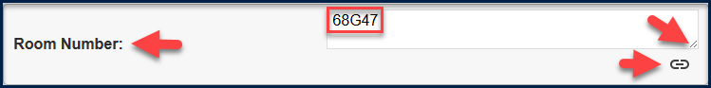
In some locations a local room number is used rather than the Estates room reference. It is helpful to put the local room reference into this field if the room is referred to in a different way from the Estates Reference. For example, the Estates Room Reference may look like: “632.00.47” yet the room is locally referred to as “68G47” or “Anne’s Lab”.

The benefit in doing this, is that the room may be searched for in the system using either reference. If there are multiple Fridges/Freezers within a location, it is useful to populate this field with the relevant criteria that identifies a specific fridge or freezer.

The field is not mandatory and can be left blank if not required.

Storage Location – Fridge / Freezer / Cabinet
18

This is an option field that allows the User to state where the stock is held. This is useful in a busy Department with multiple sources of the same radionuclide.

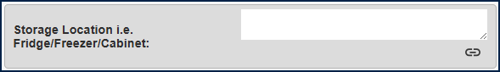

Shelf
19

In a busy Department with multiple sources, it may be helpful to identify on which shelf the source is kept, especially where there are multiple inventory items of the same radionuclide for example, where aliquots have been made for use in different instances.

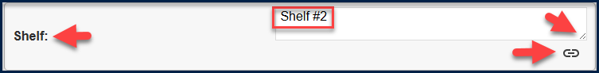

This is an optional field.

Add Another
When adding multiple sources, tick “Add Another” the system will automatically present a new page for data entry, rather than the User clicking “Add Unsealed Source” again. Once the inventory item is saved, this button will show as “Cancel” if the item is edited
Save
Click “Save” to record the new radionuclide as an item into Inventory. The form will validate the criteria entered and if not quite correct will return a red error message. For example, “the entry will exceed the Department limit for this radionuclide”. This would suggest that the User does not have permission to add the radionuclide to their inventory within their Department limit.
Once Saved, if the entry is edited and this page is re-opened, the “Save” button will turn into an “Update” button.
Cancel
“Cancel” the data entry for the form and return to the Unsealed Sources page that lists the current inventory held.

Edit Unsealed Source
Having created the inventory source, the User will be returned to the Unsealed Source Profile Page.

Unsealed Source Profile Page

This page summarizes the full data entry of the inventory item as above. It also shows additional data including links to any child data as created through division into Aliquots. On the right-hand-side it will show a date that the inventory was last updated and will also show a calculation IEAD A/D value.

The automatically generated unique ID for the radionuclide is shown in the top left-hand-side of the screen as the screen header and again as the System Reference ID on the page.

To edit the inventory entry detail for the radionuclide, click on the pencil icon shown on the right-hand side of the screen. This will return the User to the detail screens as examined in the above pages.

The “Templated fields” shown in the second half of the screen are the additional fields that the University of Oxford has added to the core out of the box Odyssey functionality. The templated fields shown below are all editable by the Safety Office.

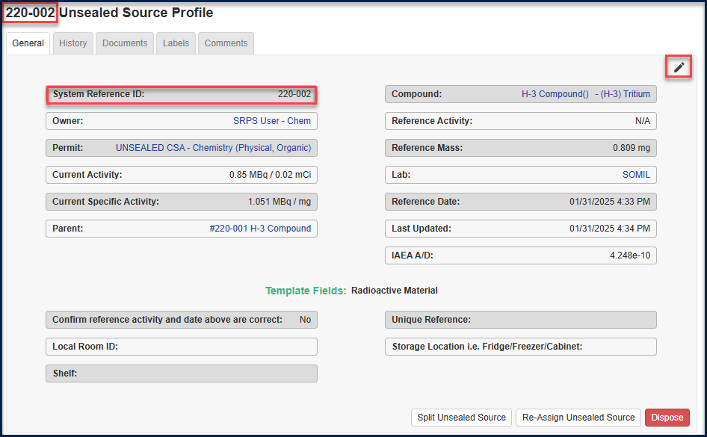

Geological Specimens
Geological Specimens are held in the Museum of Natural History in the form of “Rocks”. They remain as unsealed sources given that they contain naturally occurring radionuclides for example Thorium and Uranium. They are categorized into two groups:
- Group 1: Combined β+γ dose rate at 30cm from surface less than 2.5 μSv/h
- Group 2: Combined β+γ dose rate at 30cm from surface greater than 2.5 μSv/hn 2.5 μSv/h
At the time of writing, the University of Oxford has 189 Group 2 rocks and 780 Group 1 rocks. They will be migrated into the system electronically via a spreadsheet upload. They will be added to the system using a specific “Geological Specimens” template which is relevant to this data set only.
It is likely that there will be a handful of amendments in any given year. Confirmation of the holdings will be on a monthly basis in line with all University Departments. This is achieved through the “Monthly Possession” reporting.

Create an Aliquot – Split Unsealed Source

Action:
    - To create an aliquot, select “Split Unsealed Source”
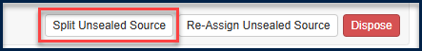
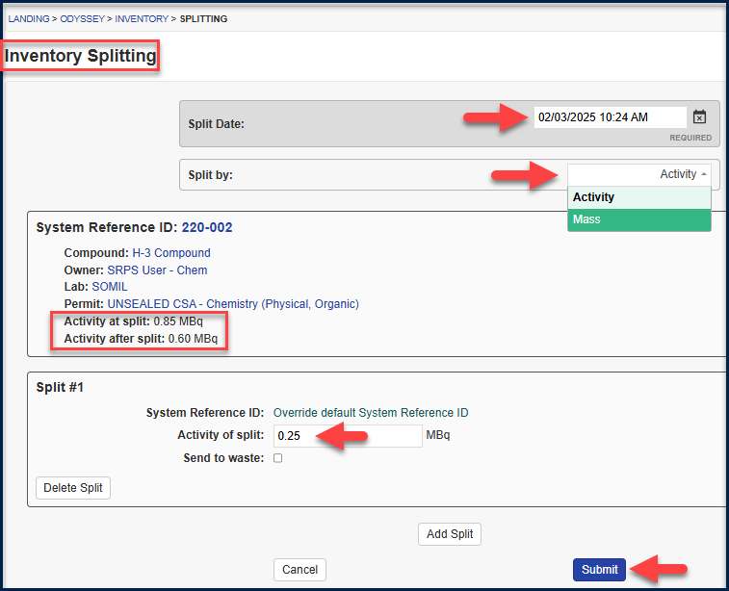

The system will default the action to the current date and time. If required, click into the white space by the date and time and enter an alternative date and time.
The type of aliquot (split) will default to Activity as recorded in MBq. Alternatively it is possible to split by Mass or Volume, depending on how the radionuclide was recorded in the first place. This example shows an aliquot in Activity MBq. Click the dropdown to show the alternative aliquot type. Note: the system will automatically calculate the remaining activity after the aliquot.
    - Click Submit and the Splitting Results will appear.

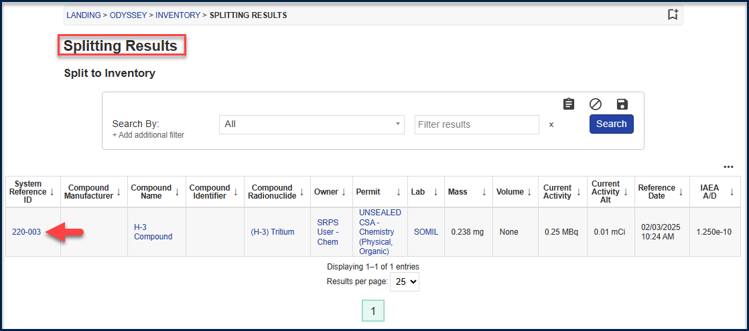
Note: a new System Reference ID is created by using the original parent System Reference with an incremental suffix number.

    - Click on the System Reference ID shown in blue and this will open the Source Profile page for the newly created aliquot.

The profile clearly shows the link back to the parent ID for the aliquot. Click on the Parent ID to return to the Profile page for the Parent source.

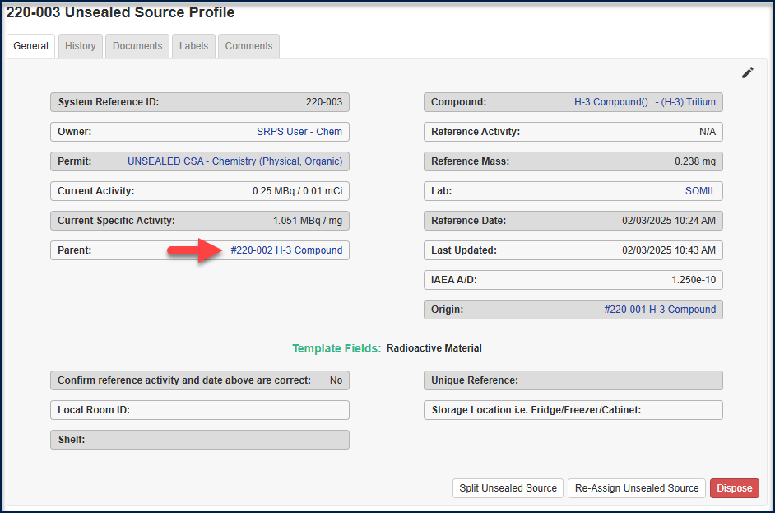
The parent source in this example was itself an aliquot of another source, so the Source Profile in this example shows both a parent and a child relationship.
All aliquots (splits) for a source are listed at the bottom of a Source Profile, with an audit trail of when and who made the aliquot, and what is the Profile ID of each aliquot made.

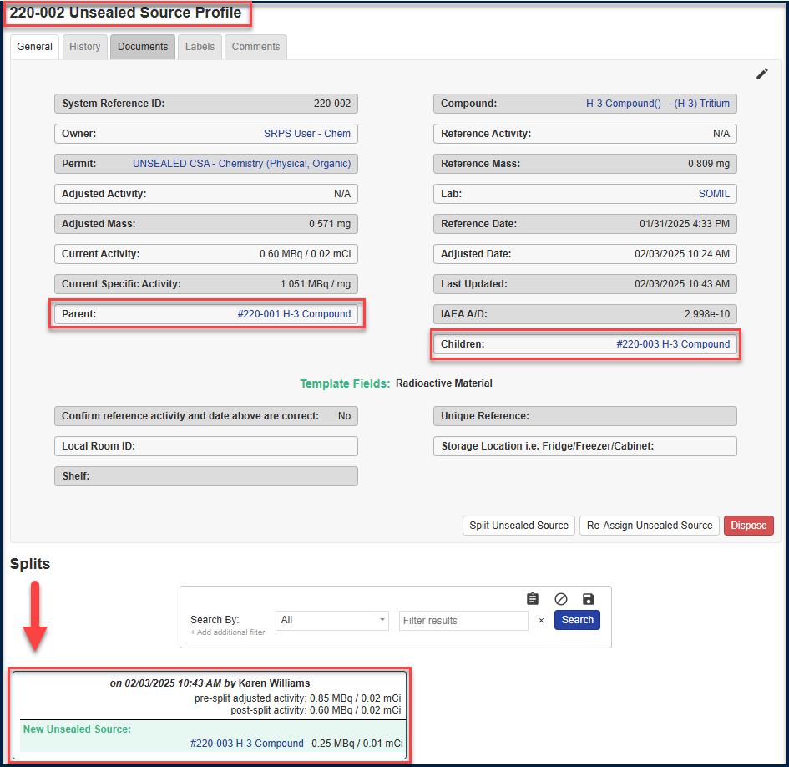

It is possible to create multiple aliquots at a time. Enter the detail for the first aliquot (split), and then click “Add Split”. Another Split box will appear, and the relevant detail can be added.
Note: multiple aliquots created at the same time from this page must be created using the same unit type i.e. all in Activity, Mass or Volume. The aliquots cannot be mixed. To create a subsequent aliquot in a different type, the User must create a new separate split each time.

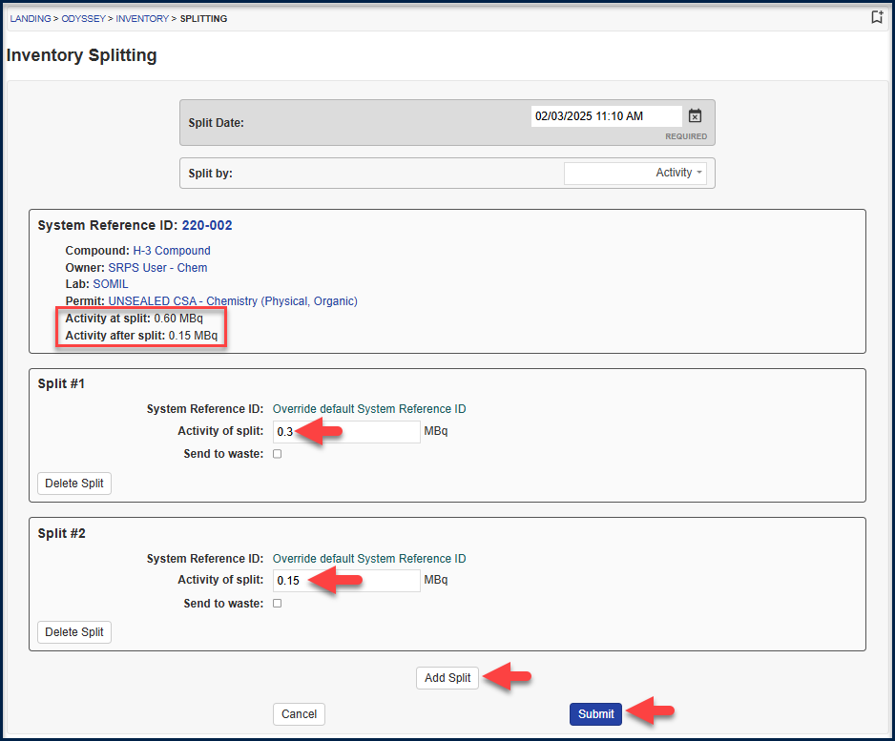
Note: each aliquot will take identical details from the Parent source in regard to the compound, lab, owner, unique reference etc. If it is required to edit these details, please visit the Source Profile page of the aliquot taken to change the detail.
This shows the result for multiple aliquots created at the same time and that are now added to the Inventory Holdings.

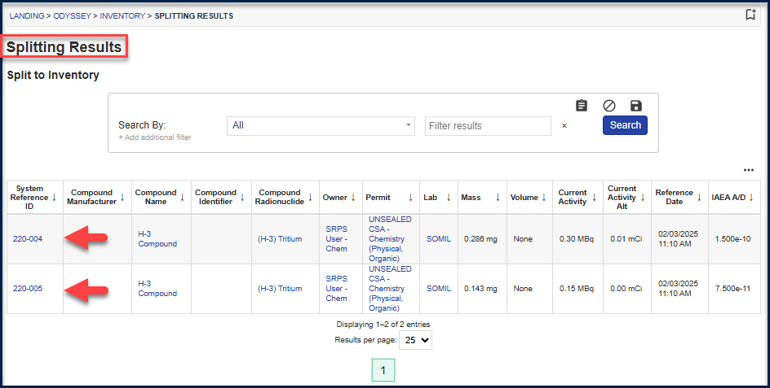

This below shows the Source Profile that demonstrates Source ID 220-002 is itself an aliquot of an original source, and that it now has a relationship with 3 child sources – aliquots.

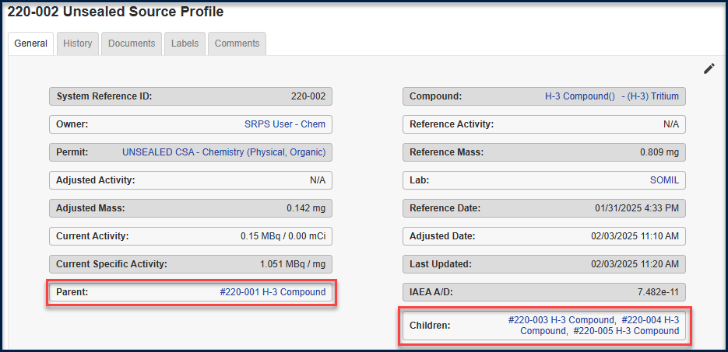

Create an Aliquot and Send to Waste

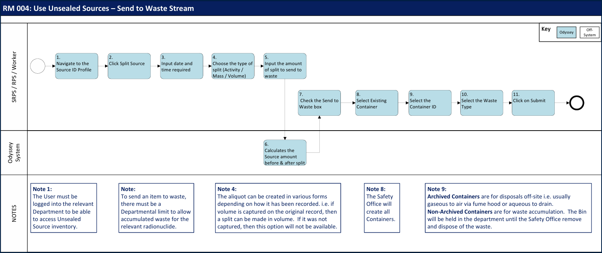
There are two types of Waste:
Accumulated Waste – where the University holds waste on the premises under certain conditions for a period of time for a limited time period as defined by the Department limits.
Waste Disposal – that is waste that is disposed of outside of the University of Oxford via a third party such as Grundons. Waste disposal activities are also governed by a set of Department limits.

A Worker may wish to create an aliquot of waste activity as a result of experimentation.
The waste may be generated as a single activity via an aliquot and sent to a waste container. A whole item of inventory stock may also be sent to a waste container as an individual stock or alongside other whole inventory items.
Action:
    - To create an aliquot of waste, select “Split Unsealed Source”


    - Enter the relevant details and click on Submit.

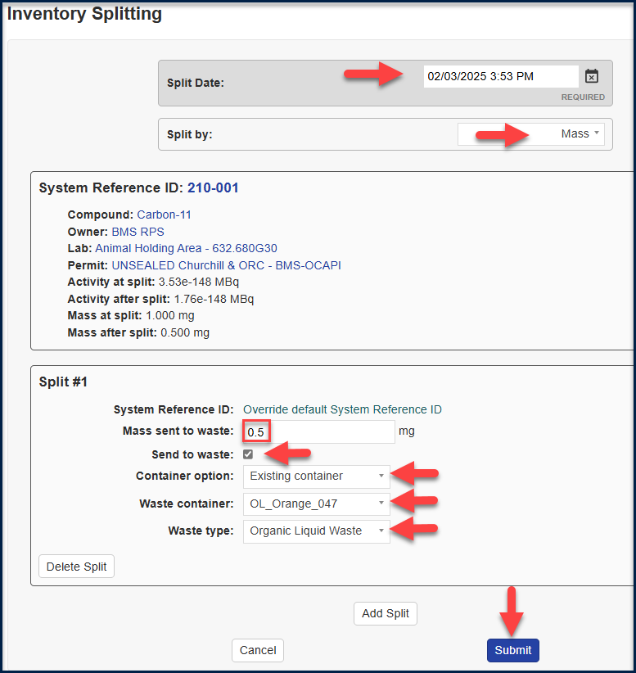
The date and time can be overwritten on this screen, if the detail is being recorded a while after the event. A choice is given to split out an aliquot for waste by Activity, Mass or Volume (depending on how the radionuclide is recorded in the first place).

The system calculates the Activity, Mass or Volume at the point of split and will show the relevant values after split.
    - Input the value to send to waste.
    - Tick the check box to “Send to waste”.
    - Select the Container Option “Existing Container”.

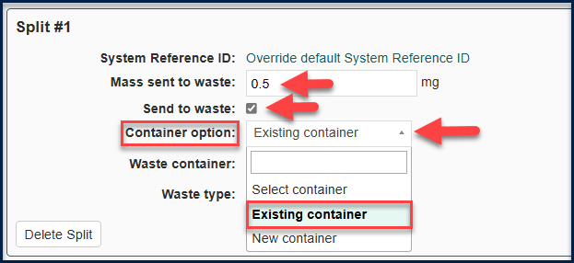

    - Select the Waste Container (bin number) from the Non-Archived section.
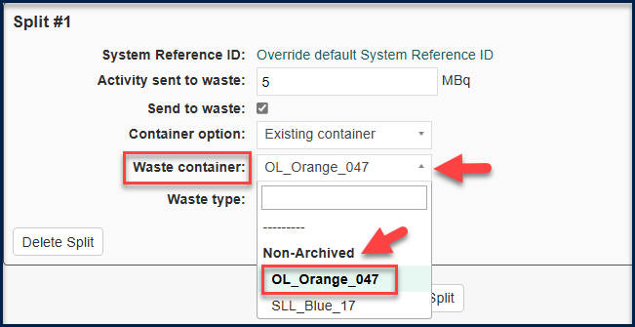
The Non-Archived section contains all the bins that are available in the waste store for the Department. In this example, there are two options available – a Blue Solid Low Level waste bin and an Orange Organic Liquid waste bin.
The Non-Archived bins are those that are open and available for selection as storage containers.
    - Select the Waste type
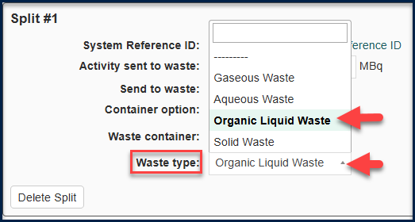
There are 4 possible waste types:
Note: Organic Liquid Waste and Solid Waste will always be added to a waste container and stored in the Department as accumulated waste until a request is made to the Safety Office for it.
Gaseous Waste may be bagged and accumulated if the Department has an accumulation limit to do so. Most often, gaseous waste will be disposed of via the fume hood within the gaseous emissions limits that are set for a Department.
Aqueous Waste may be accumulated in a container and held in a metal drum, usually for a period of no longer than 3 months (or as the limits are defined for the Department). It may also be disposed of directly to drain. Each drain (sink) in a Department will have local protocols as to the type and amount of radionuclide that can be disposed of via the drain. The Department will also have an Overall Departmental limit of Aqueous Waste defined by radionuclide.
Organic Low Level Liquid Waste may be accumulated within a Department in the Orange bin. The maximum storage period of the bin is 12 months.
Solid Low Level Waste may be accumulated within a Department in a bin. The maximum storage period of the bin is 12 months.

Change of State and Dilution of Unsealed Source
It may be necessary to amend a stock through further dilution, thus reducing the activity concentration whilst retaining the reference activity, and/or to alter the state i.e. a liquid form is turned into a solid state.
The following example reviews how to change the state of a source from powder to a solution.
    - Identify the Inventory stock to make into a solution.
The value will currently be recorded in grams with a compound mass.
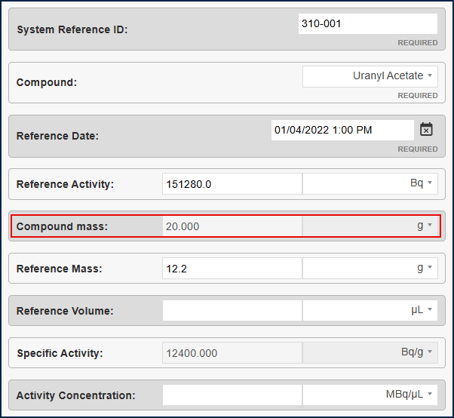
    - In put the volume of the solution either in ml or μL and note the system will calculate the reference volume.
    - Click update to save the record.
Note: the record will retain the values in mass as well as the values in volume. This will allow the user to take any subsequent aliquots from this source in either mass or volume, thus allowing for calculation with multiple states as necessitates.

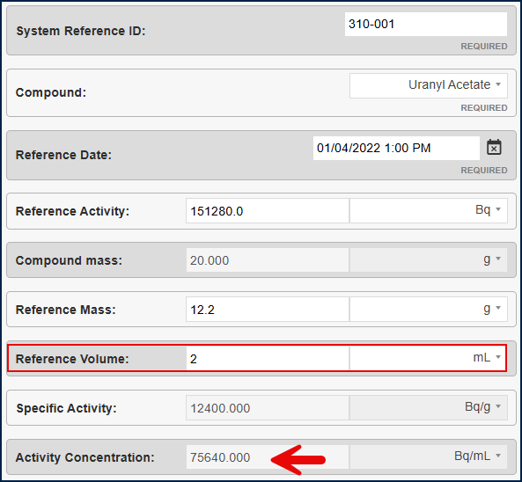
Note: the source profile will always return the units to display in summary as MBq with mg and μL.

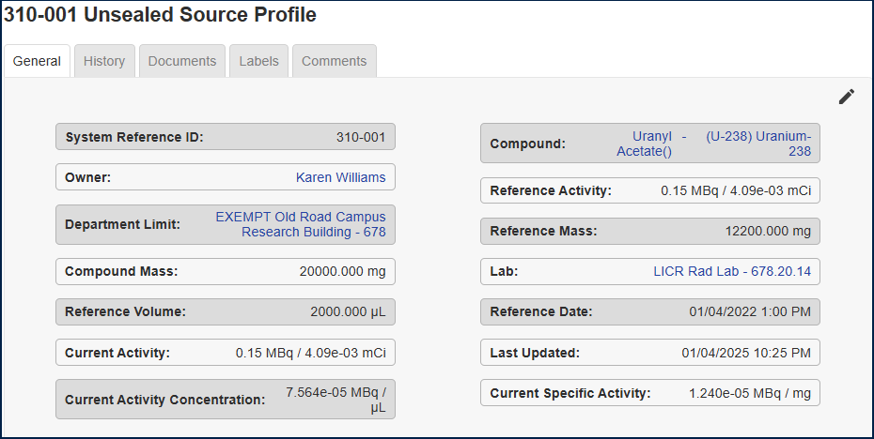

Waste Management

Bin Inventory
All bins are referred to in the Odyssey system as Waste Containers and may have a status of “opened”, “closed” or “archived”. Bins are held in the Safety Office Department until a request is made for a new bin, where it is then shipped to the Department in a “closed status”. It was agreed that all bins are shipped in a “closed status” in order that the Department will control which bin is open and in which lab. Some Departments have a number of bins that remain in their local storage until they are ready to use them. Other Departments may have only 1 or 2 bins which may be open in a lab until they are ready to be closed and collected by the Safety Office.

Add a New Waste Container
Action
    - Click on the Waste Management icon to open the Waste Management module.
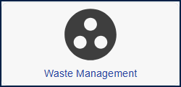
Note: The landing page for the Waste Management module will arrive at the Open Waste Containers.
Waste containers in “closed” or “archived” status can be access by selecting the relevant fields as shown across the top of the screen.
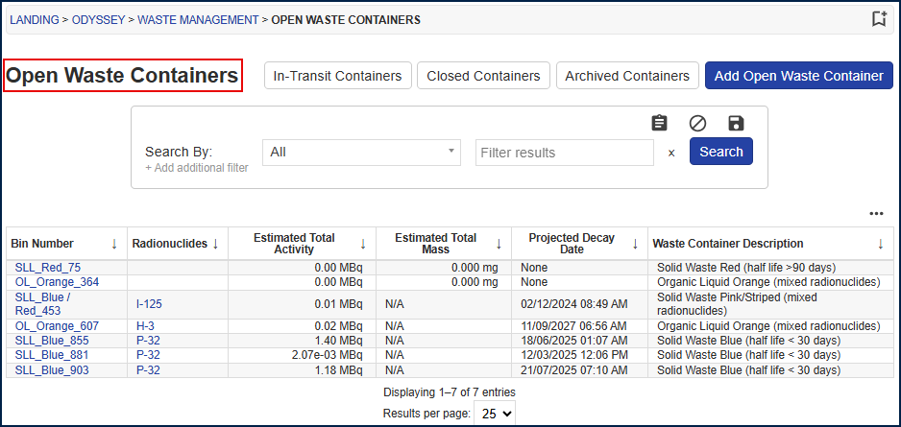
    - Select Add Open Waste Container.
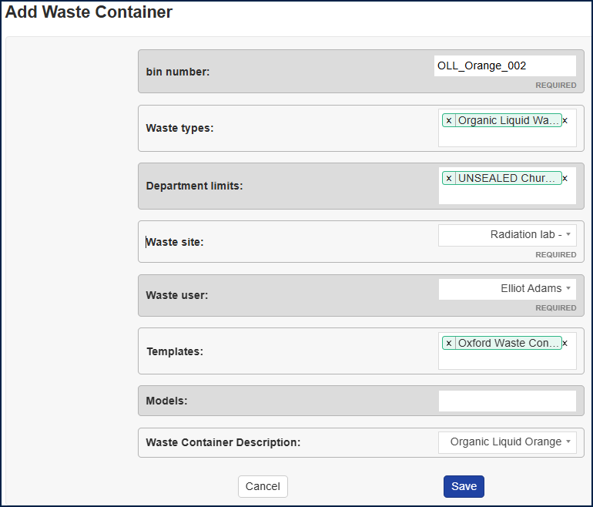
    - Input the relevant data as below:

Bin Number
These are defined by the Safety Office. Currently there are 444 bins in the Odyssey system, with circa 97 in circulation to Departments. The rest remain in the Safety Office stores.

Waste Types
There are 4 waste types. Waste can only be added by any of the types listed below if the waste type is listed on the Departmental Limit. i.e. if the container is set to hold Organic Liquid and the Departmental Limit has a possession holding for Organic Liquid Waste, the user will be able to add waste to that container.
Note: it is possible to add more than one waste type to a container if required. In practice, this is not required as the Safety Office retain control of the containers by waste type.
- Gaseous Waste
- Aqueous Waste
- Organic Liquid Waste
- Solid Waste
Note: if no waste type is input, then all waste types will be allowable.

Department Limits
Select the Department Limit against which the waste will be recorded. For example, this may be under the Exempt limit or under the Unsealed Source limit.
Note: all Waste Containers will sit under the CSA Unsealed Safety Office permit until shipped to a Department. The Safety Office will amend the permit to be the Department limit when shipped to the Department.
Note: it is possible for a container to have multiple Department limits registered against it. This will allow sources from multiple Departmental Limits e.g. from the Exempt Limits and the Unsealed Source Limits.

Waste Site
The site will be where the radiological waste container is located.
Note: if the Department has a radiological waste storage facility, the containers will be delivered to the storage location. The Department will be responsible for reallocating the container to the correct lab as and when required.

Waste User
This will be a named Safety Office person until the container is shipped to a Department. Once with the Department, the “Waste User” will be amended to be the SRPS. The amendment will be done by the Safety Office.

Templates
This is defaulted as “Oxford Waste Containers”. Do not amend.

Models
This is not currently used and is displayed as part of the core functionality.

Waste Container Description
This describes the activity for the waste container. At the time of writing the following categories are used to describe a container and can be reported on separately.
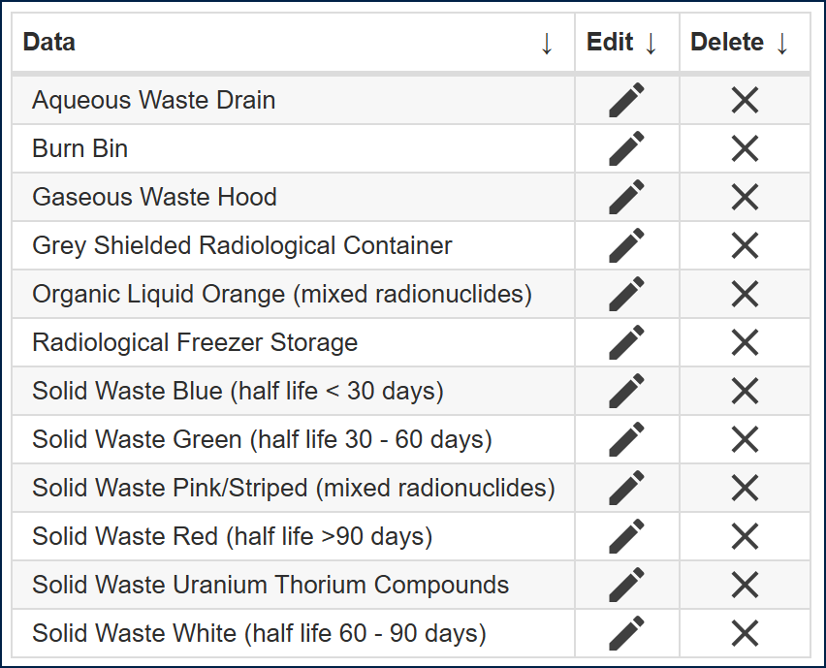

Accumulation Date
Note: the “Accumulation Date” on the container is the date on which to base the calculation for “life” of the bin. The accumulation date will be set once the first waste is added to the waste container. i.e. the 12 month counter will start from this point. (i.e. this is nothing to do with the status of opening or closing the bin). The accumulation date should always be based on the date of the oldest entry to the bin. Note: it is possible for the date to be overridden by bin transaction activity. i.e. emptying another container into an existing container. Please ensure that the date always reflects the date of the oldest transaction into the waste container.
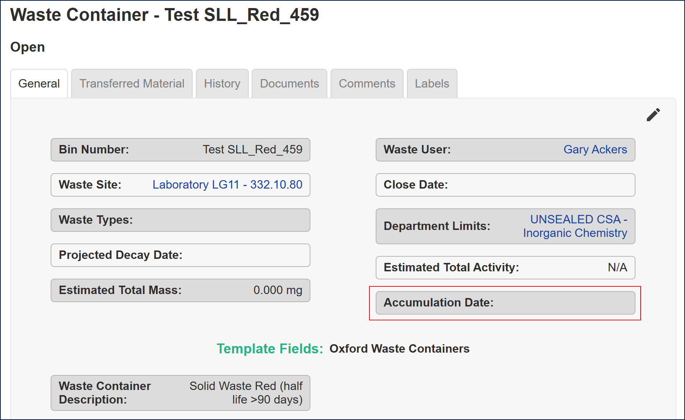

Sealed Source Inventory
A sealed source may be held under EA Permit conditions and recorded in the system as a Registered Sealed Source Department Limit or a Category 5 Department Limit. If the activity limit is low enough, the Sealed Source may be exempt from EA Department limits and will be held on the system under the Exemption Order Department limit.
Assumptions:
- The Safety Office will add all Sealed Sources to the system.
- The Department SRPS is accountable for the Sealed Source and will be cited as the Owner of the Sealed Source in the system.
- The Sealed Source will be assigned to a Room or a Lab as a home location.
- The Safety Office and the SRPS may enter Leak Test data against the Sealed Source.
- The Safety Office and the SRPS will be enabled to maintain all data in regard to a Sealed Source.
- Sealed Sources are not disposed of as there is no facility within Department to disposed of Sealed Sources.
- The Safety Office will have permission to Archive a Sealed Source in order to remove it from live Inventory and reporting. It will be visible as archived data. Note: archiving of Sealed Sources is considered a rare occurrence.
- It will not be possible to delete the Sealed Source.

Add Sealed Source

Action
    - Click on the Sealed Sources tile to open the Unsealed Source inventory.
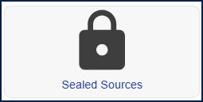
Note: the sealed source module landing page opens and displays all active sealed sources for the Department.
    - Click Add Source
Input the relevant data – example as follows. Note: the top half of the screen are required fields.
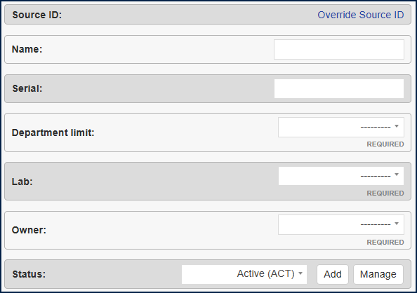
8
1
7
4
2
3
5
6

This second half of the screen is optional except for the Count (number of sources to be added) as seen at the bottom of the screen.

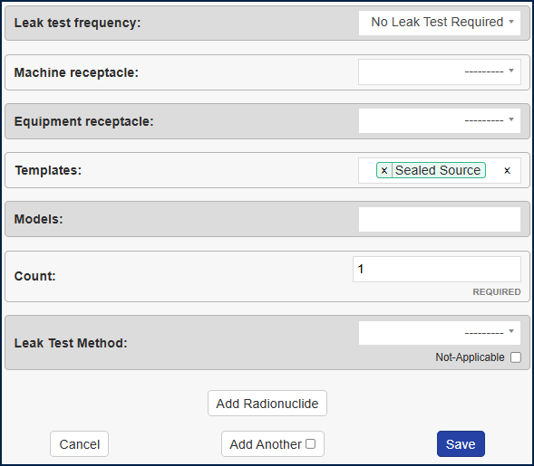
16
13
15
14
12
9
10
11

Source ID
1
This can be a system generated number and may be overridden.
However, the University of Oxford have chosen to always override the Source ID, hence it will now display as “Override Source ID” rather than a system generated number, in order to prompt the User to input the correct Source ID. Note: if the User ignores the message and leaves the Source ID defaulted to the text “Override Source ID” then the system will automatically generate a unique number.
It is agreed that the Source ID will be the same as the Serial number. The Serial number will already be identifiable on the physical source (or housing). Keeping the Source ID and the Serial number identical will drive consistency ensure no duplication and will make reporting and identification in the system much easier.
2
Name
This is the name of the Sealed Source radionuclide and will also incorporate the Source ID at the end of it.
Serial
3
This is the Serial number of the Source and is identical to the Source ID. The Serial number is found on the physical Source itself and/or the housing of the physical Source it the Source is too small to have a physical label.
4
Department
This is the Departmental Department limit under which the source will be accounted for. For example, if the source is to be used in the Physics Department, it might be listed under the “SEALED CSA Physics” Department or alternatively it might be listed under the “EXEMPT Denys Wilkinson Building” Department.
5
Nuclide Authorisation
Each radionuclide listed on the Department is shown with a nuclide authorisation. This describes the conditions for use of the radionuclide. For example, a sealed source might be listed on the Department with one or more Nuclide Authorisation:
e.g. the radionuclide might be shown on the same Department twice.
- Line one, radionuclide with 2x sealed sources of Stontium-90 at 2GBq.
- Line two, radionuclide with 8x sealed sources of Strontium-90 at 1.48GBq.

The Nuclide Authorisation field is used to select the correct use when adding the radionuclide against the Department i.e. in this example the Strontium source either at the 2GBq value or the 1.48GBq value.
Note: if you mouse over the Nuclide Authorisation options given, the system will provide the details for the authorised use and note the number of sources allowable against the criterial shown.
6
Lab
This is the location where the source is held. The lab will be visible if it has been listed on the Department limit for the Department. If it is not visible, it will need to be added to the Department before it can be selected for use with the sealed source.
7
Owner
This represents the person accountable for the source in the system. The sealed source report can be run by “owner” to identify all sources attributable to an individual. The owner of the source can use the source, make sub-divisions and create waste as required.
8
Status
This is a required field and will default to be marked as “Active” when adding a new sealed source to the system. When a source is ultimately disposed of, the status will change to be “Inactive”. This will ensure that the source is not accounted for in current inventories but is still retained in the system for audit purposes.

Leak Test Frequency
9
This is as defined in the protocols. The maximum possible length will be annual. Some sources may require more frequent leak test accountancy.
Machine Receptacle
10
If the source is associated with a machine for example a calibration source used with a scintillation counter, the machine record can be associated with the source record.
Equipment Receptacle
11
If the source is associated with a radiation protection instrument for example a calibration source in a handheld monitor, the RPI record can be associated with the source record.
Archived Date
12
This is used to record the data of disposal of a source record. The source is archived to preserve an auditable record.
Templates
13
A template is used to record specific criteria against a particular type of source. For example, a HASS Source will have very specific criteria to record, which a non-HASS source will not. Therefore, the “HASS” template will be selected to prompt the additional required fields.
In regards to Nuclear Materials – all ONR data will have a “Safeguards” template added which details specific criteria for use with Safeguards reporting and controls. More information in regard to the Safeguards template is found in the Templates section below.
Models
14
A LEGO spaceship model would look good. 
15
Count
This is the number of sealed sources added with the same criteria input above. It is a required field and will default to 1 unit.

Add Radionuclide
16
Add the relevant Isotope data. The radionuclides listed for selection in this part of the screen will relate to the Department selected and the Nuclide Authorisation chosen. The values may be recorded as original activity, original mass, and specific activity. Note: once two of the values have been input, the system will automatically calculate the third value.
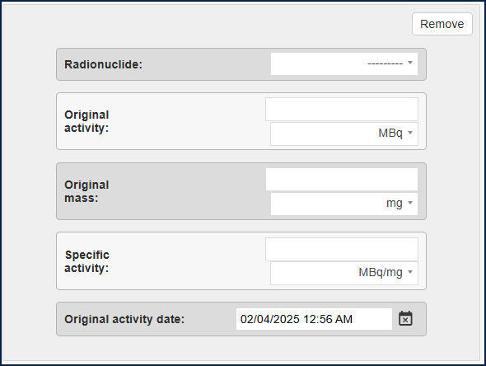
Save the details and the system will automatically exit this page.
Once the source is added, a summary screen is presented back detailing the input. The pencil on the top right-hand-corner indicates that the User may make edits to the details of the source.
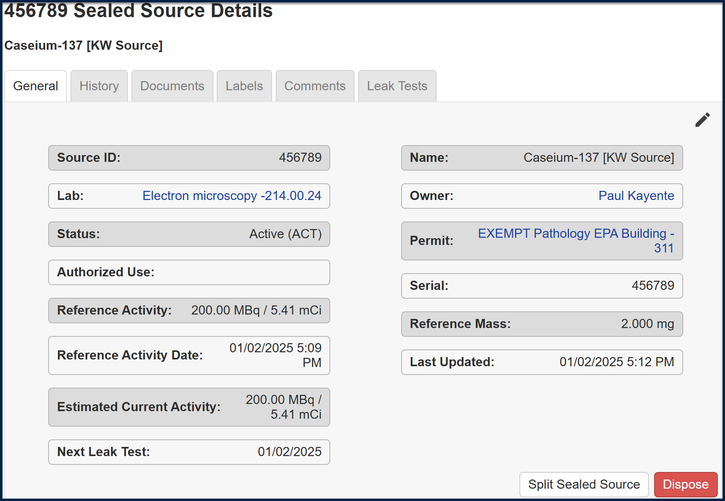

History
The History tab will keep an audit trail of all actions taken against the source created. It will provide detail of the User name, date and time of the change. Current information is shown in green and the outdated information is shown in red.
For example, below the source ID was amended.
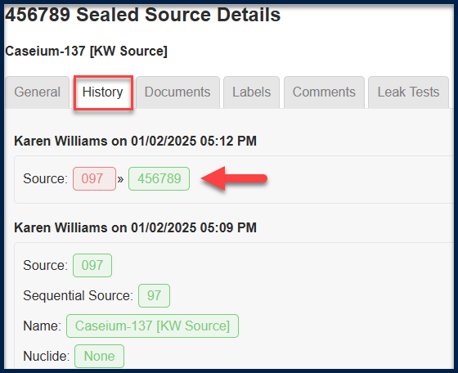

Documents
Add a document for example a manufacturer’s certificate or photo of the source if required.
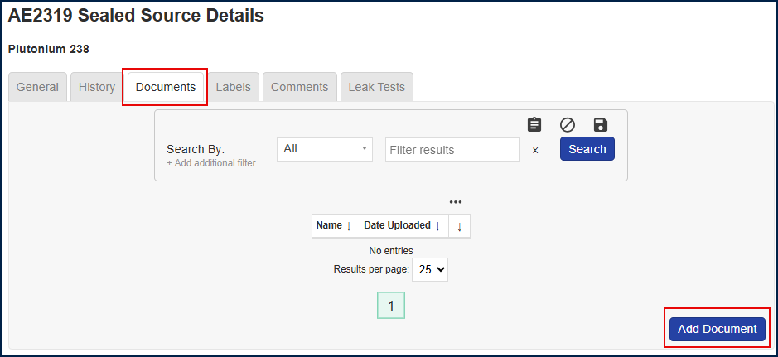

Labels
Labels can be created for all Inventory, Machines and RPI. The functionality is the same throughout. It is possible to have a mix of free text, specific fields and to generate a QR code.
At the point of writing, the University of Oxford has chosen not to explore this option further.
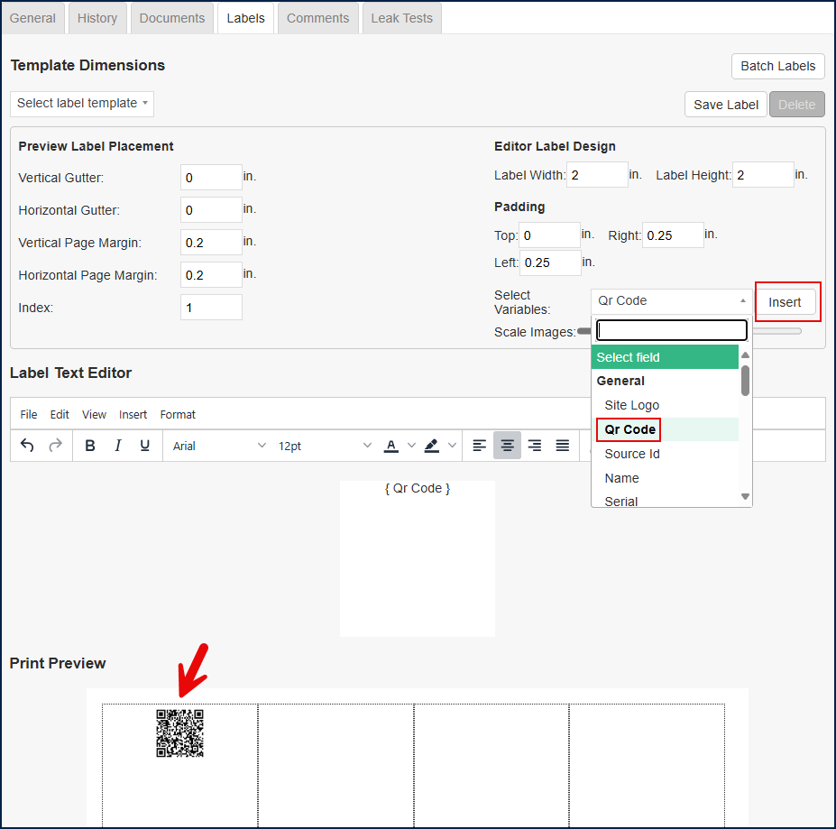

Comments
Comments may be used to add specific details about the source that are general and do not fit into any of the prescribed fields. For example, information about the manufacturer, or details about how the source is to be kept secured.

Leak Tests and Contamination Surveys
STILL TO DO – Elliot Adams?

Add a leak test
A leak test is performed

Add a Contamination Survey
A Contamination Survey is performed

Radiation Protection Instruments (RPI) / Equipment

RPI
All RPI are held in the Equipment Catalogue module. The working assumption is that anything in this module relates to monitoring equipment.
Action
    - Click on the RPI tile to open the Equipment catalogue.
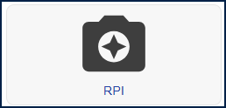

Note: all RPI are held in the “Equipment Catalogue”. The landing page will list all RPI owned by the Department.
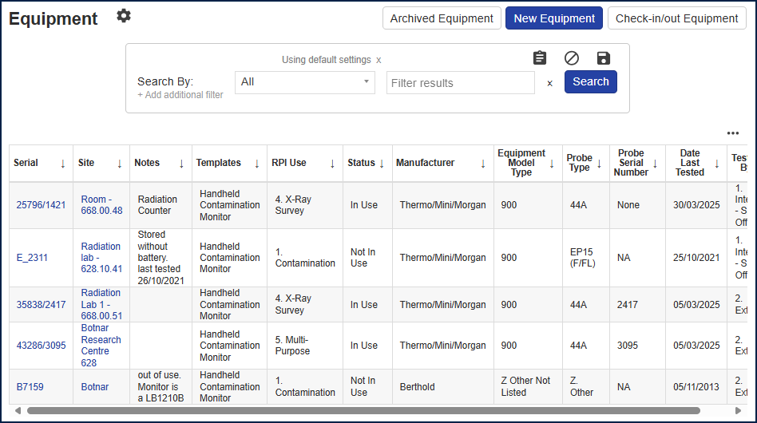
To modify the selection of columns shown, click on the 3 dot ellipsis show to the top right-hand-side of the main table and toggle the columns on/off that you wish to be displayed.
It is also possible to use the “Search By” functionality to filter the results, for example to search for all RPI that have an “in use” status. RPI must be tested and confirmed as working on an annual basis. This my be done either internally by the Safety Office or by an external third party.

Add New RPI
Action
    - Select “New Equipment” to open a new RPI profile.
The top half of the screen is governed by the system out of the box functionality. The bottom half of the screen from “RPI Use” onwards is templated data created from University of Oxford requirements.
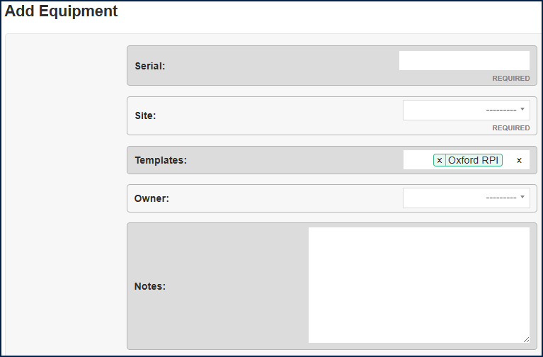
Serial:
This is the serial number of the monitoring equipment (i.e. not the serial number of the associated probe – that information can be seen further down in the “Probe Serial Number” field). The serial number should found on the piece of RPI.
Site:
This is the location where the RPI is kept, i.e. the lab or the room. The field allows the input of a room or lab already in the system that is associated with the use of ionising radiation. Note: some Departments have chosen to hold the RPI at Department level rather than lab level as the RPI moves location many times within the Department.
Templates:
This field will always have the “Oxford RPI” as a template. Further templates can be added to this field to categorise the type of RPI.
Equipment templates and equipment models can be added/amended by the ‘Safety office’ permission, S/RPS + Workers cannot change amend or add templates and models.
At the time of writing, there are no additional fields on any of the subsequent templates. Their use is purely for categorisation which will allow filtering by category when reporting.
Templates are used to distinguish different equipment types and can contain different input fields. In Odyssey the following templates are available:
- Portable Radon Monitor
- Installed Environmental Monitor
- Handheld Dose Rate Monitor
- Handheld Contamination Monitor
- Electronic Personal Dosimeter (EPD)
- Oxford RPI (default template applied to all equipment added).
When adding a piece of RPI the correct template should be added. When reporting and running the Equipment Report you can then select one or more of the templates.
Owner:
This is the person accountable for the RPI – usually the SRPS. The field allows the selection of a system user.
Notes:
This is a free text field and is reportable. It also appears on the main landing page as a column. Hence it is advised to use the field conservatively.
RPI Use
This is used to describe the objective of the RPI and what it does. There are 5 choices.
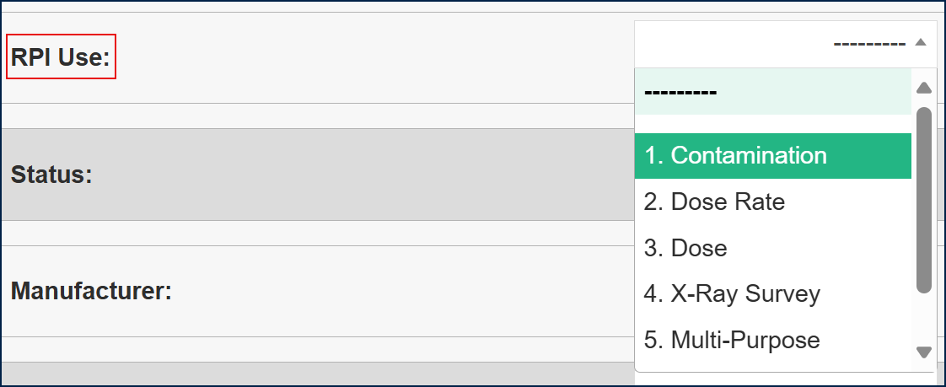
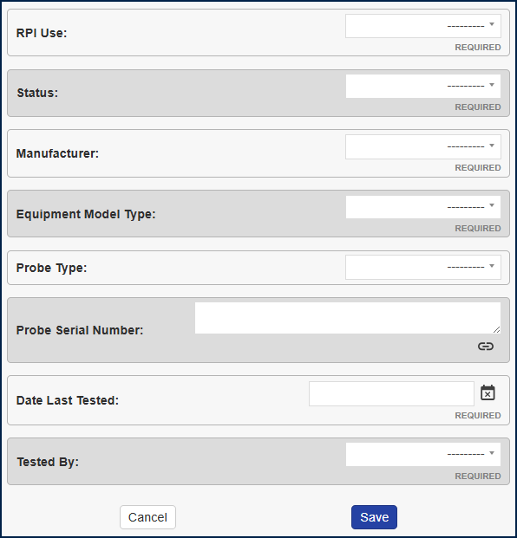
Status
The RPI will either be “in use” or “not in use”. If it is not in use, then it will not be picked up by the Safety Office in any reporting and so will not be tested. It is a requirement than any piece of RPI or equipment that is in use is checked and certified on an annual basis as working correctly should it be in use.
Manufacturer:
This is a required field with selection from a pre-defined list. If the Manufacturer required is not listed, there is an option to use “Z other”. This option will be monitored over time and if it is used for a common alternative, then that specific manufacturer can be added to the list.
Equipment Model Type:
As with the Manufacturer field above, this is a required field with a selection from a pre-defined list.
Probe Type:
This is not a required field, as not all RPI have probes. It also uses a pre-defined list. If not relevant, please leave this field blank.
Probe Serial Number:
Some probes are interchangeable against the RPI and so will have separate serial numbers. Other types of RPI have a fixed probe that is not interchangeable and hence will not have a separate serial number.
Date Last Tested:
This will be the date that the RPI was tested for compliance either by the Safety Office or by an external Third Party. The testing is conducted on an annual basis and it is a required field.
Tested By:
This is to confirm, whether the annual test was conducted internally by the Safety Office or whether the RPI was sent offsite for an external Third Party to test.

Machine Management

Machine Listing
All Machines are held in the Machine Management module. At the time of Go-Live all X-Ray sets were migrated to this module. It was agreed that only ionising radiation generators would be added to the system and captured in this module. Therefore Liquid Scintillation Counters, Benchtop Counters and HASS Irradiators will not be added as they contain sources of ionising radiation, but do not themselves generate ionising radiation.
Action
    - Click on the Machines tile to open the Machines Management module.
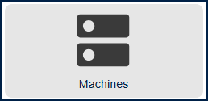
The landing page for Machines is configured at University of Oxford site level. To amend the view, select the ellipsis icon (3 dots) and click the white space next to the fields listed.
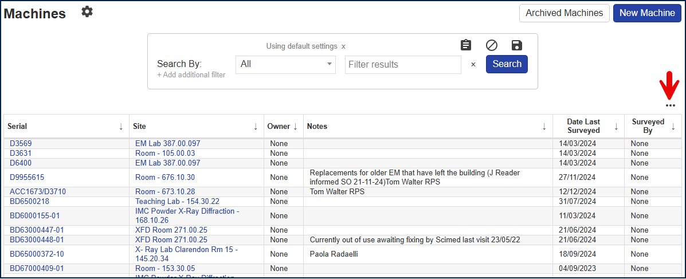

This will open a view of all remaining fields available for selection and also allow the removal of existing fields.

The User will select the fields as required. Click Apply to make the change. Click the save icon, Click Set for site and Activate to apply the configuration across the site for everyone. Note: this needs to be applied when logged in as University of Oxford.

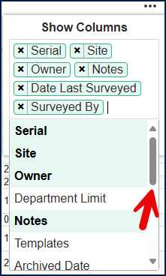 | 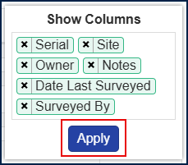 | 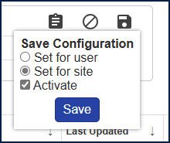
 | 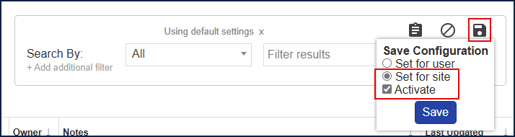

Note: at the time of writing, this configuration can be set by the Safety Office and Admins only. If a Department were to request a specific configuration, this could be set at a local level by the Safety Office and/or the Admins.

Add Machine
Action
    - Select “New Machine” to open a new Machine profile.
The top half of the screen is governed by the system out of the box functionality. The bottom half of the screen from “Status” onwards is templated data created from University of Oxford requirements.
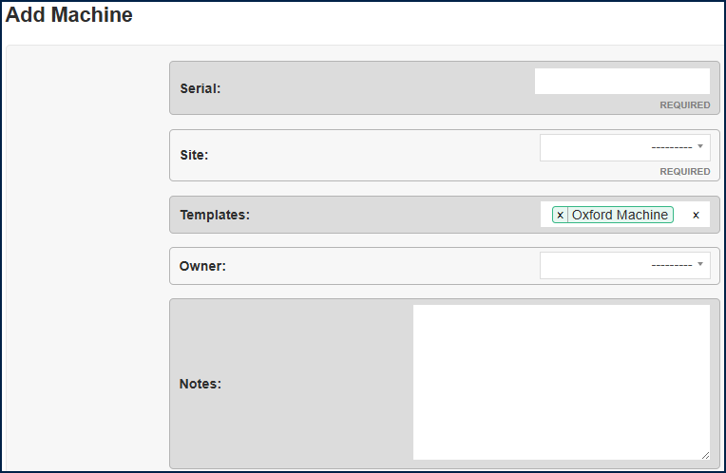
Serial:
This is the serial number as found on the machine.
Site:
This is the location where the machine is held, i.e. a room or a lab. Note: for the room to be selected as a site against the machine profile, the room must first be authorised as a “machine site”. This is different from the RPI where the room or lab does not need to be specifically authorised to hold RPI.
Click on “Sites” from the Machine Management Overview. Note: this is accessed by clicking on “Machine Management” from the breadcumb trail along the top of the screen.
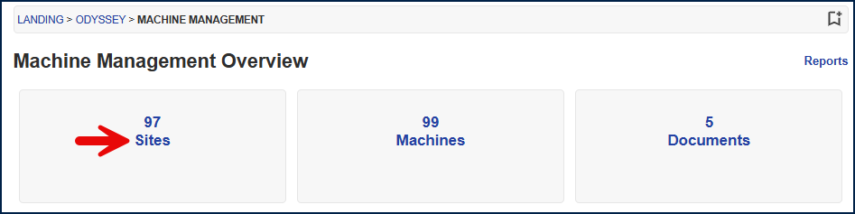
If the site is not listed, select the “Mark Site For Use” to add it to the available list of rooms and lab for use with Machine Management.
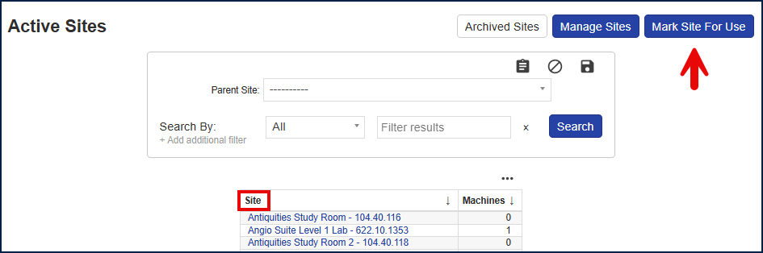
The listing from this page will show all authorised “Machine Sites” and will give a count of the number of machines currently held in each site.
Machine Templates:
This field will always have the “Oxford Machine” as a template. Further templates can be added to this field to categorise the type of Machine.
Machine templates and machine models can be added/amended by the ‘Safety office’ permission, S/RPS + Workers cannot change amend or add templates and models.
Templates are used to distinguish different machine types and can contain different input fields.
In Odyssey we have the following machine templates:
- X-ray analysis
- Z Other
- Oxford Machine (default template applied to all machines added).
- Irradiator (X-ray)
- Accelerator
- Electron Microscope
- X-ray imaging

When adding a machine, the correct template should be added. When reporting and running the Machines Report you can filter on one or more of the templates.
Owner:
This is the person accountable for the Machine – usually the SRPS. The field allows the selection of a system user.
Notes:
This is a free text field and is reportable. It also appears on the main landing page as a column. Hence it is advised to use the field conservatively.

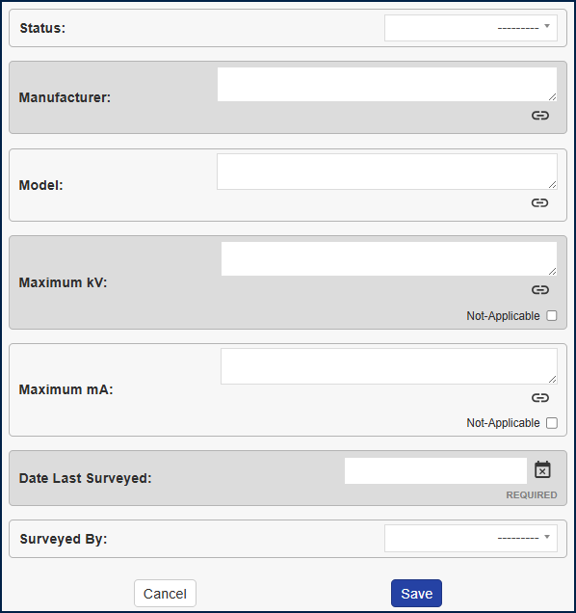
Status
The Machine will either be “in use” or “not in use”. If it is not in use, then it will not be picked up by the Safety Office in any reporting and so will not be tested. It is a requirement for all machines to be tested and certified on an annual basis. Note: this is the formal annual machine survey and does not in any way substitute the departmental checks and leak tests prior and post assay.
Manufacturer:
This is a free text field to note the name of the Manufacturer. At the time of writing, the options were considered too variable to provide a drop down list.

Model:
This is to note the specific model/type of the Machine.
Maximum kV:
This is the SI derived unit for voltage and a required field.
Maximum mA:
This is the unit to state the number of X-Ray photons produced by the X-Ray tube at the setting selected. i.e. the quantity of X-Rays. It is a required field.
Date Last Surveyed:
This will be the date that the Machine was tested for compliance either by the Safety Office or by an external Third Party. The testing is conducted on an annual basis and it is a required field.
Surveyed By:
This is to confirm, whether the annual test was conducted internally by the Safety Office or whether an external Third Party conducted the test.

Reporting

Report Listing
Report | Description
Unsealed Source Holding | This details all Unsealed sources to which a User has access to see. The report will list the holdings by the Owner assigned in the system to the source. If no filters are selected, the system will return all sources that are held in the Department with all values.  A summary table at the bottom of the report will show the total reference activity for each type of radionuclide held.  This will be used to confirm monthly holdings.
Radionuclide Receipt Summary | This provides a listing of the number of sources held for each radionuclide in the Department. It will also show a total reference activity for each type of radionuclide.
Sealed Source | This details all Sealed sources to which a User has access to see. The report will list the holdings by the Owner assigned in the system to the source. If no filters are selected, the system will return all sources that are held in the Department with all values.  A summary table at the bottom of the report will show the total reference activity for each type of radionuclide held.
Lab Category Summary | This details all rooms and buildings that have been marked as labs within the Department.
Lab and Personnel Unsealed Source Use | N/A - we do not record data for this report
Unsealed Source Use Card | N/A - we do not record data for this report
Unsealed Source Use Card Status | N/A - we do not record data for this report
No Unsealed Source Use | N/A - we do not record data for this report
Radiation Safety Summary | N/A - we do not record data for this report
Waste Container | This details all waste containers within the Department. The default setting will look at
Waste Container Radionuclide | In ERROR
Sites | This shows the structure of the Department, listing the Building, the Department and the Rooms.
Department Report | This details by individual Department all radionuclides and their associated limits, the authorised locations for use with inventory and all Users assigned to the Department.
Labs and Associated Departments | This lists all labs that have been identified for work with radioactive sources and their associated Department.
Department Summary | This lists all Departments created in the system. This is brilliant as it can be used to find all Departmental limits created for a Department.
Radionuclide Possession | This details all source holdings and waste accumulation by radionuclide for the selected Department. It will show the limits given, and the holdings activity in value and as a percentage of the limit. Also shows the number of inventory items.
Radionuclide Possession Totals | This summarises the detail in the previous report.
Radionuclide Department Disposal | This details all disposals by radionuclide for the selected Department. It will show the limits given, and the holdings activity in value and as a percentage of the limit. Also shows the number of disposal entries as a total at the bottom of the report
Radionuclide Department Disposal Totals | This summarises the detail in the previous report.
Authorised Personnel | This lists all individuals and shows which Department they have permissions for.
Machines | This shows all Machines with associated relevant data, and lists by type if that information has been captured.
Machine Sites | This is a list of all locations that have been tagged to allow machines.
Equipment | This lists all RPI and where relevant by type if that information has been captured.
Lab Inventory | This details all unsealed source inventory lines by lab. Very similar to the current data sheets for a lab. It also captures all Machines and RPI associated with the lab. Note it does not show Sealed Sources.
Lab Unsealed Source | This totals for the lab the unsealed source inventory listing by radionuclide.
Lab | This details all of the sites marked as labs and shows which Departments include them for use. This can be restricted further to show just the labs that currently contain inventory.
Department Audit Summary | No data available
Department Audit | No data available
User Audit Summary
User Audit
Pre-Audit
Sites
Personnel Holding Unsealed Sources
Personnel
Group Summary
Group

Inventory Templates and Configurations

Adding Inventory Templates
Templates are used to create a specific set of criteria for a particular activity. For example, all nuclear radionuclides must be recorded with specific fields in addition to the information recorded against other non-nuclear radionuclides.
Within Odyssey there are:
- Radionuclides Templates (there is one: PET radionuclides)
- Compound Templates (not used)
- Unsealed Source Templates (there are four, Safeguard Material, HASS Source, Radioactive Material, Geological Specimens)
- Sealed Source Templates (we have two, Sealed Source and Safeguard Material)
Inventory Templates may also be used to create a report with a specific set of criteria, where it is required to repeatedly run the report.
To create an inventory template that is usable across all Departments, it is necessary to ensure that the User is logged into University of Oxford i.e. top level.

The Safeguards Inventory Template
This template allows the input of a specific set of fields that are required for reporting and audit purposes of nuclear materials. An example of the template is as below
Input the relevant source detail as below.
When changing the Safeguards template – need to create the changes on both the Sealed and Unsealed templates.

The HASS Template
This controls permissions. When the HASS template is added to a sealed source (Cs-137), permissions will restrict the users who have visibility of the HASS sources. The restrictions applied will allow only the users who have HASS cited on their worker registration to be able to view and report on the HASS sources (alongside the system Admin role).
Note: HASS sources are held against a completely separate Departmental limit (as denoted with an “H”) at the end of the title. This will ensure that the monthly accountancy reports for HASS will also be restricted to only those users who have specific access.

Geological Specimens Template
This was developed solely for the Museum of Natural History to allow for the migration of rocks onto the Odyssey system. At the time of writing, the template is complete however the migration process is still under development.

Permissions, Worker, S/RPS

Permissions Highlevel
Insert high level
Summary/Dashboards | RRW | RPS | SRPS | SO | Admin
Unsealed Sources | ✔ | ✔ | ✔ | ✔ | ✔
Sealed Sources | ✔ | ✔ | ✔ | ✔ | ✔
Waste Management | ✔ | ✔ | ✔ | ✔ | ✔
Machines | ✔ | ✔ | ✔ | ✔ | ✔
RPI | ✔ | ✔ | ✔ | ✔ | ✔
Labs | ✔ | ✔ | ✔ | ✔ | ✔
My Account | ✔ | ✔ | ✔ | ✔ | ✔
Reporting | ✗ | ✔ | ✔ | ✔ | ✔
Send Registration Form | ✗ | ✔ | ✔ | ✔ | ✔
Registration Progress | ✗ | ✔ | ✔ | ✔ | ✔
Active Workers in My Department (Reporting) | ✗ | ✔ | ✔ | ✔ | ✔
Monthly Disposal Return (Reporting) | ✗ | ✔ | ✔ | ✔ | ✔
Monthly Possession Return (Reporting) | ✗ | ✔ | ✔ | ✔ | ✔
Reporting | ✗ | ✔ | ✔ | ✔ | ✔
Other Areas
Add Sites/Locations/Labs | ✗ | ✗ | ✗ | ✔ | ✔
Add Simple Data | ✗ | ✗ | ✗ | ✔ | ✔
Add Template Data | ✗ | ✗ | ✗ | ✔ | ✔
Manage Custom Lists | ✗ | ✗ | ✗ | ✗ | ✔
Add Users/Make Admins | ✗ | ✗ | ✗ | ✗ | ✔
Apply Permission Groups | ✗ | ✗ | ✗ | ✗ | ✔

User must have work registration AND be added to Department Limit
Add details

Unsealed Sources Permissions
https://unioxfordnexus.sharepoint.com/:x:/r/sites/ITServices-ITS877-RadioactiveMaterialsManagement-Restricted-new/Shared%20Documents/Restricted%20-%20new/Business%20Analysis/Radiation%20Materials%20Management/Modules_Permissions_Draft.xlsx?d=wa45a27f03e324b288293235c866ab9a8&csf=1&web=1&e=A1j11u

Sealed Sources Permissions

APPENDIX

Department Structure
The structure is split into 5 area that follow the Departments:
- CSA – The Central Science Area
- GLAM – Gardens, Libraries and Museums
- The JR – John Radcliffe
- Churchill & ORC – The Churchill Hospital and Old Road Campus
- The NOC – The Nuffield Orthopedic Centre

Document History
Change History/Review
Date | Version | Author | Summary of the change
20 March 2025 | 0.1 | ITS877 Project Team | System guide created for go live of the Odyssey System
 | 1.0 | Paul Kayente (URPO) | Reviewed and approved

